**Technical Assessment for**

**Improved Cattle Feed Quality**

Sector: Avoided Methane

Agency Level: Farm

Keywords: Methane, Livestock Production

MAY 2021

**Prepared by:**

Kristina Colbert, Research Fellow

Senorpe Hiablie, Research Fellow

Martina Grecequet, Research Fellow

Mamta Mehra, Senior Fellow



27 GATE 5 RD., SAUSALITO, CA 94965 [info@drawdown.org](mailto:info@drawdown.org) [www.drawdown.org](http://www.drawdown.org)

Table of Contents

List of Figures 4

List of Tables 5

Acronyms and Symbols Used 6

Executive Summary 7

Literature Review 9

1.1. State of practice 9

1.2. Adoption Path 24

1.2.1 Current Adoption 24

1.2.2 Trends to Accelerate Adoption 26

1.2.3 Barriers to Adoption 27

1.2.4 Adoption Potential 29

1.3 Advantages and disadvantages of Improved Feed Quality 30

1.3.1 Arguments for Adoption 30

1.3.2 Adoption Burdens 30

1.3.3 Similar Solutions 31

1.3.4 Additional Benefits and Burdens 34

2 Methodology 36

2.1 Introduction 36

2.2 Data Sources 36

2.3 Total Addressable Market 37

2.3.1 The Drawdown Food Supply Model 37

2.3.2 Estimation of the Total Addressable Market 38

2.4 Adoption Scenarios 41

2.4.1 Reference Case / Current Adoption 41

2.4.2 Custom Adoption Scenarios 43

2.4.3 Project Drawdown Scenarios 45

2.5 Model Inputs 45

2.5.1 Direct and Indirect Emissions Inputs 45

2.5.2 Financial Inputs 47

2.5.3 Other Inputs 48

2.6 Assumptions 48

2.7 Limitations/Further Development 49

3 Results 50

3.1 Adoption 50

3.2 Climate Impacts 52

3.3 Financial Impacts 53

4 Discussion 55

4.1 Benchmarks 56

5 References 57

6 Glossary 64

# List of Figures

Figure 1.1 World census data on livestock animals. Top panels show animal populations in millions of heads. Bottom panel shows chicken population in billions of heads. Source: FAOSTAT (2021). 11

Figure 1.2 The production of methane through enteric fermentation and the loss mechanisms. Source: Aguirre-Villegas et al., (2017). 12

Figure 1.3 Global methane emissions from enteric fermentation for 1961-2019. Calculated from FAOSTAT animal census data and IPCC 2019 emission factors. 13

Figure 1.4 Enteric methane contributions by country, 1961-2019 (Tg-CH4) from top contributors (countries accounting for 99% of the total). Calculated from FAOSTAT animal census data and IPCC 2019 emission factors. UK & NI* = United Kingdom and Northern Ireland 15

Figure 1.5 Fraction of global enteric methane emissions from each livestock category in 2014. Calculated from FAOSTAT animal census data and IPCC 2019 emission factors. 16

Figure 1.6 Fraction of global enteric methane emissions from each region in 2014. Calculated from FAOSTAT animal census data and IPCC 2019 emission factors. 16

Figure 1.7 Emission intensities for livestock products as modeled in GLEAM 2. Source: FAO (2019). 18

Figure 1.8 Annual distribution of global feed use. Source: Gro-Intelligence (2017 20

Figure 1.9 Global dry matter intake by type of ingredient for cattle. Data sourced from Mottet et al. (2017). 25

Figure 1.10 Fraction of dry matter intake by ingredient for cattle feedlots, mixed, and grazing systems in OECD90 and non-OECD90 regions. Data sourced from Mottet et al. (2017). 25

Figure 2.1 Total Addressable Market (TAM) for the various Project Drawdown Scenarios (PDS). 39

Figure 2.2 Fraction of TAM protein content coming from milk and bovine meat for the Project Drawdown Scenarios (PDS). 40

Figure 2.3 Current Adoption of Improved Feed Quality and Nutrition by Region and Production System 42

Figure 2.4 World Adoption of Improved Feed Quality through 2050 44

Figure 3.1 World Annual Adoption of Solution (2020-2050) 51

Figure 3.2 World AnnualGreenhouse Gas Emissions Reduction (2020-2050) 53

Figure 3.3 World Annual Operating Cost Reduction (2020-2050) 54

# List of Tables

Table 1.1 Regional averages of dairy and beef cattle feed compositions (% of diet). Source: GLEAM based on input data from literature, national inventory reports, expert knowledge, and databases (Opio et al., 2013). 21

Table 1.2 Food Production Solutions Comparison: On-Farm Economic Impacts 34

Table 1.3 Food Production Solutions Comparison: On-Farm Impacts Social and Ecological Impacts 35

Table 2.1 Distribution of Production Systems by Region 40

Table 2.2 Current Adoption by Region and Production System 42

Table 2.3 Definitions of Limited, Ambitious, and Maximum Adoption for Regional Groupings and Production Systems 43

Table 2.4 Climate Inputs 46

Table 2.5 Financial Inputs for Conventional System and Solution 47

Table 3.1 World Adoption of the Solution 50

Table 3.2 Climate Impacts 52

Table 3.3 Impacts on Atmospheric Concentrations of CO2-eq 52

Table 3.4 Financial Impacts 54

Table 4.1 Benchmarks 56

# Acronyms and Symbols Used

|  |  |
| --- | --- |
| CH4 | Methane |
| CO2 | Carbon Dioxide |
| CO2eq | Carbon dioxide equivalent emissions |
| C3, C4 | 3-carbon or 4-carbon molecule grass species |
| FAO | Food and Agriculture Organization of the United Nations |
| GHG | Greenhouse Gas |
| GLEAM | Global Livestock Environmental Assessment Model |
| Gt | Gigatonne (1 billion metric tons) |
| H2 | Hydrogen |
| kg | Kilogram (1 thousand grams) |
| LCA | Life-cycle Analysis |
| MMT | Million Metric Tons |
| Mt | Megatonne ( 1 million metric tons) |
| 3-NOP | 3-nitrooxypropanol organic compound |
| OECD90 | Organization for Economic Cooperation and Development |
| PDS | Project Drawdown Scenarios |
| ppm | parts per million |
| REF | Reference Scenario |
| RRS | Reduction and Replacement Solutions |
| TAM | Total Addressable Market |

# Executive Summary

Project Drawdown defines *improved cattle feed quality* as a set of feeding strategies that lower enteric methane emissions by changing the composition and or nutrient intake of cattle. This solution replaces conventional low-digestible rations such as high-fiber grasses and corn residue at various levels of adoption. About 3.40 Gt-CO2eq in methane emissions came from global livestock enteric fermentation in the year 2014. At an increasing rate of 0.02 Gt-CO2eq per year, enteric methane is projected to reach 3.84 Gt-CO2eq per year by 2030 and 4.33 Gt-CO2eq per year by 2050. The relatively short lifespan of methane in the atmosphere provides opportunity to limit global warming on the short term, thus achieving temperature reduction targets more quickly (Collins et al., 2018). Acting to reduce the livestock sector’s footprints could help avert negative climate impacts.

Extensive studies of enteric methane mitigation strategies have identified feeding strategies as having the highest mitigation potential. The adoption of improved and financially feasible cattle feed and feed management scenarios to reduce the emission of enteric methane and associated indirect impacts were modelled. These feed strategies included *high-quality forages* (low fiber, easily digestible, high soluble carbohydrates such as legumes and cool season annuals), *feed additives* (certified methane reducing compounds), and *feed supplements* (concentrates and grains). Feeding strategies are mainly influenced by production system types, agroclimatic zones and socioeconomic status. Data on emissions from conventional and solution implementation were obtained from published reports from on-site farm analyses, process-based farm modeling, the Global Livestock Environmental Assessment Model (GLEAM), and databases including FAOSTAT.

The impacts of increased adoption of the improved cattle feed quality were modelled for three adoption scenarios based on two reference (business as usual) cases. *Reference 1* assumed conventional population projection while *Reference 2* accounted for the population impacts of the *Drawdown Family Planning* and *Educating Girls* solutions. The Project Drawdown Scenarios; PDS1, PDS2, and PDS3 assumed conservative, progressive, and ambitious adoption approaches. The Total Addressable Market (TAM) for the livestock feed quality solution was based on projected total production of meat and dairy products from grazing and non-grazing cattle from the *Drawdown Food Supply Model*. It was assumed that production system types, machinery requirements, and land use did not change through to 2050 for solution adoption.

Results show that by 2050 the percentage of the total addressable market for cattle-derived protein served by the improved feed solution under PDS1, PDS2, and PDS3 would be 28.0%, 45.2%, and 62.4%, respectively. These represented 16.1 billion kg protein under PDS1, 26.0 billion kg protein for PDS2, and 35.9 billion kg protein for PDS3. The associated climate impacts would be annual emissions reduction of 0.24 GtCO2-eq, 0.83 GtCO2-eq, and 1.42 GtCO2-eq for PDS1, PDS2, and PDS3, respectively by 2050. The cumulative total emissions reductions taking into consideration all scenarios ranged from 4.4 Gt CO2-eq – 26.6 Gt CO2-eq for the thirty-year timespan between 2020 and 2050. The cumulative reduction accounts for up to 20% of projected total global methane emissions from the livestock sector.

The financial impacts of the solution were in the form of net operation savings ranging from US$0.34 trillion to US$ 1.99 trillion (2020-2050) and lifetime cashflow savings of between US$ 0.55 trillion and US$ 3.22 trillion correlating directly to the level of adoption. The positive economic impacts are associated with increased cattle productivity from the improved nutrition the solution provides.

Whereas the current improved feed solution was confined to reducing enteric methane from cattle protein, opportunities for further reduction may be found in buffalo and small herbivore feed production systems. Feed additives that might soon emerge on the market and macroalgae also hold promise for enteric methane reduction in herbivores. Project Drawdown also analyzes manure management in livestock (including non-ruminants) production systems as an separate solution for additional emission reduction opportunities.

# Literature Review

## State of practice

The biomass of the earth’s livestock populations is estimated to be twice that of humans (Bar-On et al., 2018) for which it provides food, livelihood sustenance. Edible animal products are sources of high-quality nutrients and calories that nourish many while non-edible animal products have multipurpose uses including clothing, leather, fertilizer, and plastics. Services such as draft power, transportation, and companionship are also provided to humans by animals. Livestock also serve as financial security and define the social and cultural identity of many peoples (Revell, 2015). With an estimated value of at least $1.4 trillion, economies around the world are supported by the production and trade of agricultural products (Thorton, 2010). Seventy-five percent of farmland belong to smallholders (less than 2 hectares each in size) that rely on livestock for their livelihoods (Lowder et al., 2016). With the growing global population, increasing demand for livestock products has been projected. This will potentially drive increases in livestock production and lead to increased competition for natural resources and negative environmental impacts including increases in greenhouse gas emissions. According to estimates by Gerber et al. (2013), livestock production contributes at least 7.1 Gigatons of carbon dioxide equivalent (Gt-CO2eq) emissions, or nearly 14.5% of global emissions. Pelletier and Tyedmed (2010) have estimated that livestock production to meet 2050 demands as projected by the FAO may directly increase livestock-related greenhouse gas emissions by as much as 39%. Actions taken today to reduce the livestock sector’s footprints could avert negative impacts on the environment and improve quality of life. In this report, the adoption of improved and financially feasible livestock feed and feed management scenarios to reduce the emission of methane, a potent greenhouse gas is analyzed.

#### Project Drawdown Solution Definition

Project Drawdown defines *improved cattle feed quality* as a set of feeding strategies that lower enteric methane emissions by changing the composition and or nutrient intake of the animal. Some common feed strategies Drawdown considers are *high-quality forages* (low fiber, easily digestible, high soluble carbohydrates such as legumes and cool season annuals), *feed additives* (certified methane reducing compounds), and *feed supplements* (concentrates and grains). This solution replaces conventional low-digestible rations such as high-fiber grasses and corn residue as various levels of adoption.

#### Livestock Census and Trends

Livestock census data from the FAOSTAT (2021), was analyzed for trends in cattle, buffalos, goats, pigs, sheep, chickens, horses, camels, and asses and mules populations (Figure 1.1). In 2014, the global livestock population consisted of approximately 27 billion animals. Of those animals, by far, the largest category (78%) was chickens. The second largest animal category (4%) was non-dairy cattle having 1.16 billion animal heads. Dairy-producing cattle made up another 0.27 billion heads. Global sheep populations also made up another 4%. Other significant animal groups consisted of pigs, goats, and buffalos. The smallest animal groups having less than 60 million heads in total were horses, asses and mules, and camels.

For almost every animal category, trends over the last six decades indicated that global populations have increased (Figure 1.1). The most substantial increase was from chickens (443% increase). In particular, broiler chickens raised for meat consumption have outpaced layer chickens, raised for their eggs. Considerable population growth (182% increase) from goats has also occurred over the last several decades. Much like chickens, goat herds are raised as a means for consolidating food security in the developing world. These increasing trends indicate that the global demand for meat has risen, especially in developing nations.

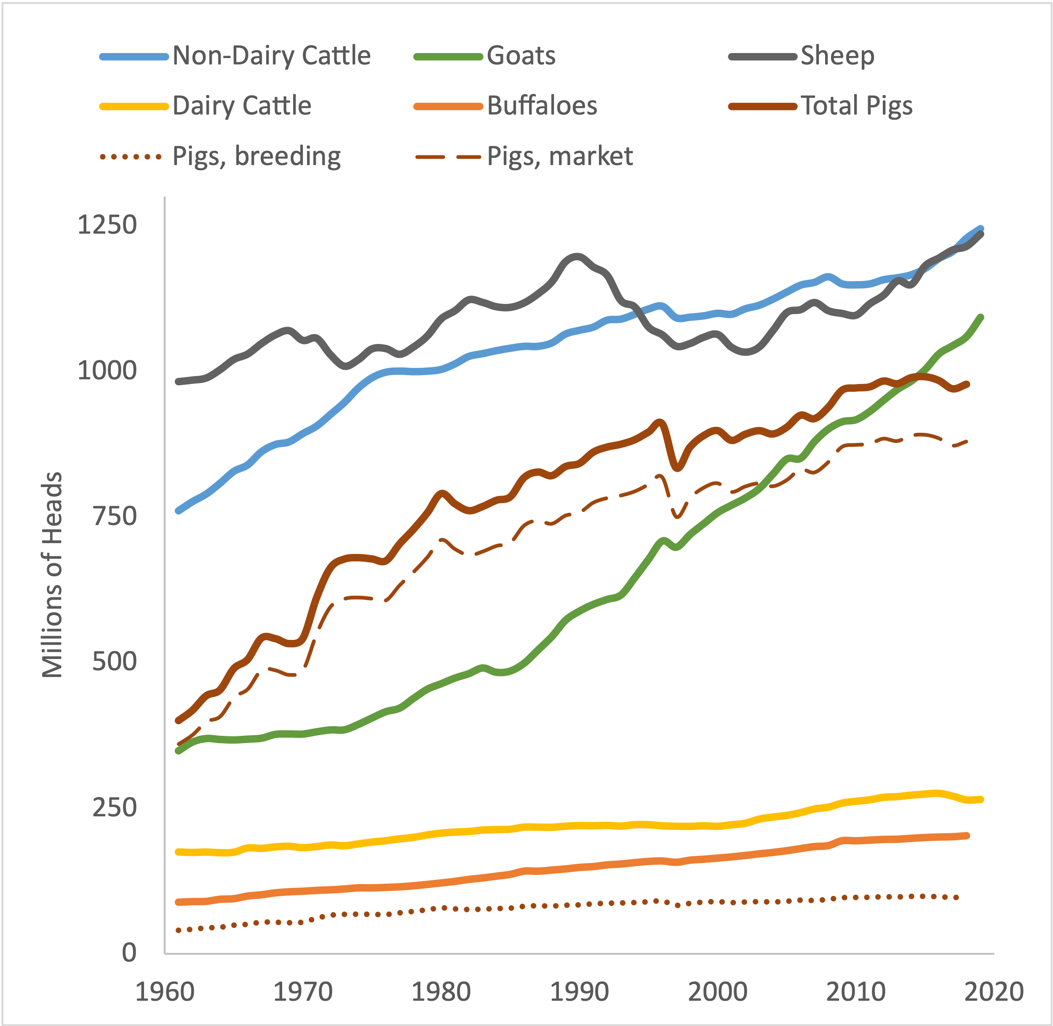 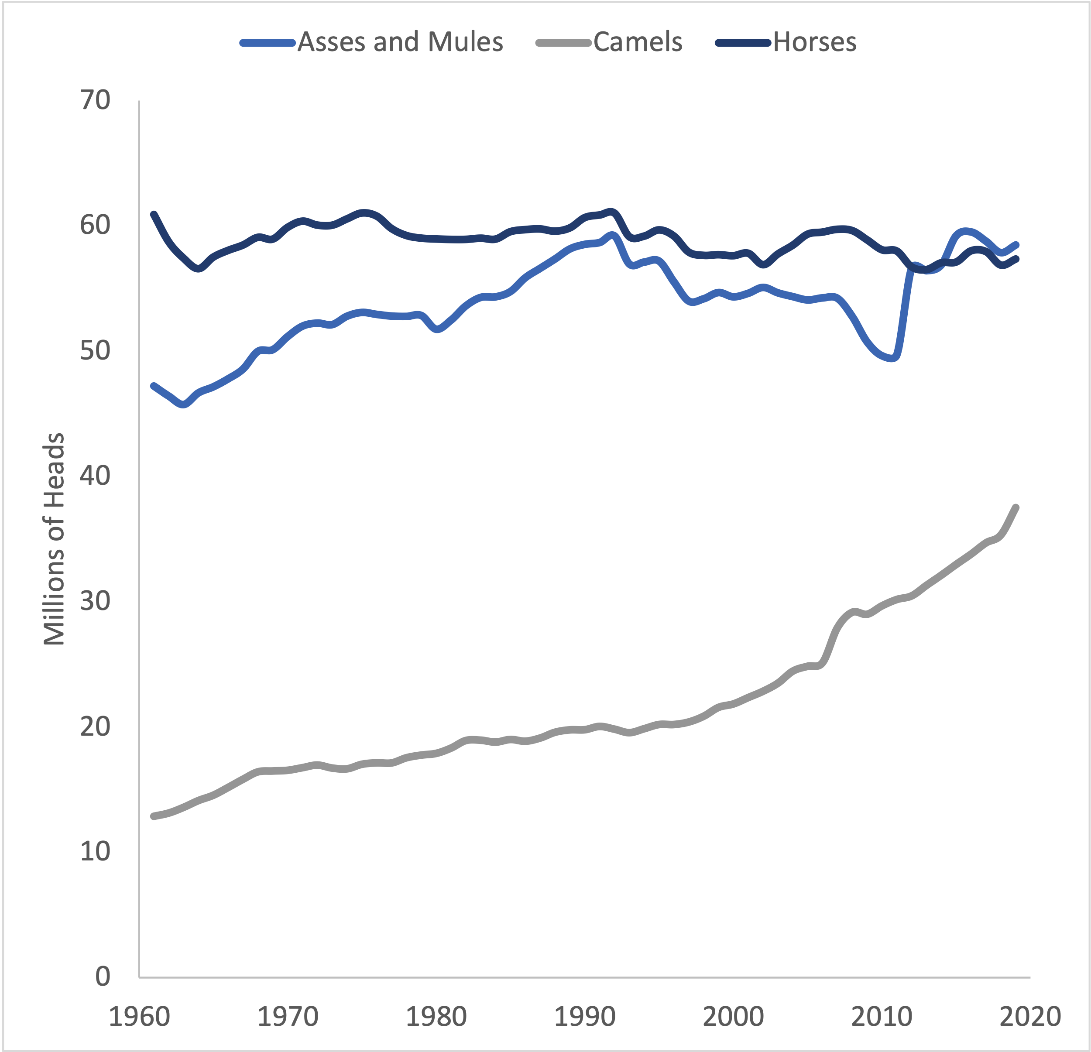

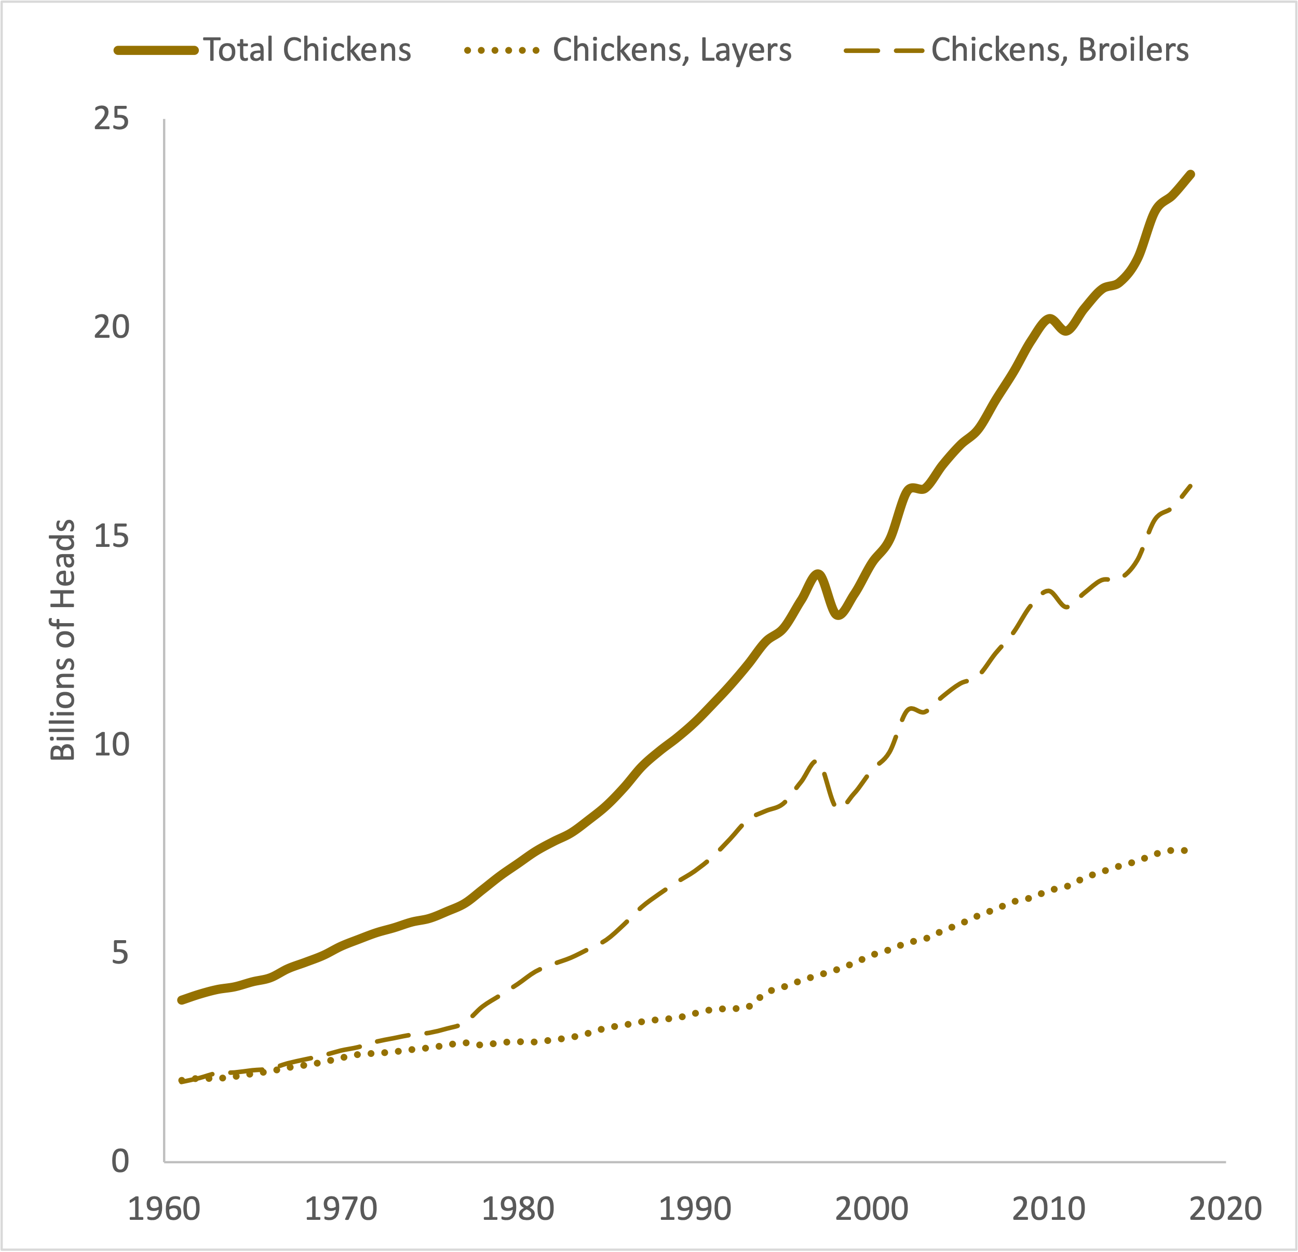

Figure 1.1 World census data on livestock animals. Top panels show animal populations in millions of heads. Bottom panel shows chicken population in billions of heads. Source: FAOSTAT (2021).

Other significant animal population trends include the rise in cattle (non-dairy and dairy) and buffalo. Over the last twenty years, dairy cattle populations have risen 20% while non-dairy cattle populations have risen 14%. In 2014, global cattle population reached 1.4 billion heads. While cattle are widespread across the world, more than 42% of cattle are raised in the top four producing countries: Brazil, India, the United States, and China. Buffalo are more geographically confined to South Asia and Eastern Europe, where they are most widely used as pack animals for heavy haulage and tilling fields. They also provide small farms a source of milk and meat.

#### Methanogenesis from Enteric Fermentation

Ruminant animals (cattle, buffalo, camels, sheep, goats) possess multichambered stomachs. The first of four fermentation chambers is the rumen. Within the rumen is a complex microbiome consisting of a wide diversity of specialized protozoa, fungi, and bacteria which enables the animal to digest and obtain nutrients from tough cellulosic plants and grains (McSweeney and Mackie, 2012). Ingested feed is broken down or fermented in the digestive track by the microorganisms as shown in Figure 1.2 (Aguirre-Villegas et al., 2017).

Figure 1. The production of methane through enteric fermentation and the loss mechanisms. Source: Aguirre-Villegas et al., (2017).

The fermentation process is a multi-step process. Under anaerobic (low oxygen) conditions, carbohydrate molecules from plant fibers are degraded into simple molecules for absorption into the bloodstream of an animal. Simple sugars are fermented into volatile fatty acids to be used as a source of energy and fuel (Bhatta et al., 2007). As a by-product of the energy source, carbon dioxide (CO2), and hydrogen gas (H2) are produced (Broucek, 2014). The primary pathway to produce methane gas is from the main substrates, CO2 and H2 (Hegarty and Gerdes, 1999). Hydrogen-dependent species called methanogenic archaea use the hydrogen substrate to reduce carbon dioxide into methane (CH4). Predominantly, methane is produced within the rumen stomach (87%), and only a small amount (13%) is produced by methanogens located in the large intestines (Torrent and Johnson, 1994). Even for non-ruminant animals (pigs, poultry, and horses), methane is produced within the intestines, however, not at the extent of ruminant animals. Generally, the methane gas escapes from the animal’s digestive system through eructation (i.e. belching, 95% to 97%) and rectal emissions (3% to 5%) (Munoz et al., 2012; Aguirre-Villegas et al., 2017). On a typical day, a U.S. dairy cow can release as much as 0.45 kg to 0.64 kg of methane (Aguirre-Villegas et al., 2015).

#### Global Estimate of Enteric Methane Emissions

Enteric fermentation in ruminants is a major concern for global warming as ruminants produce 58% of agriculture’s methane emissions (Knapp et al., 2014). As a greenhouse gas, methane produced during the fermentation process has a significant effect on the global temperature. Over a span of 100 years, methane is 28 times more potent at trapping heat in the atmosphere than carbon dioxide (Myhre et al., 2013). However, this effect is most impactful within the first decade of being emitted since methane has a shorter lifespan (on the order of 12 years). The relatively short lifespan of methane in the atmosphere provides an opportunity to limit global temperatures rising on the short term, and thus achieve temperature reduction targets more quickly (Collins et al., 2018).

The total methane emissions from livestock enteric fermentation using the Tier 1 approach of the Refinement Guidelines for National GHG Inventories (IPCC, 2019) was determined. As shown in Figure 1.3, a global average of 3.40 Gt-CO2eq (range: 3.24 - 3.56 Gt-CO2eq) methane emissions were emitted by livestock enteric fermentation in 2014. Globally, enteric methane was found to have increased at an average rate of 0.02 Gt-CO2eq per year since the 1960s (Figure 1.3). At this rate, enteric methane is projected to be 3.84 Gt-CO2eq/yr by 2030 and 4.33 Gt-CO2eq/yr by 2050.

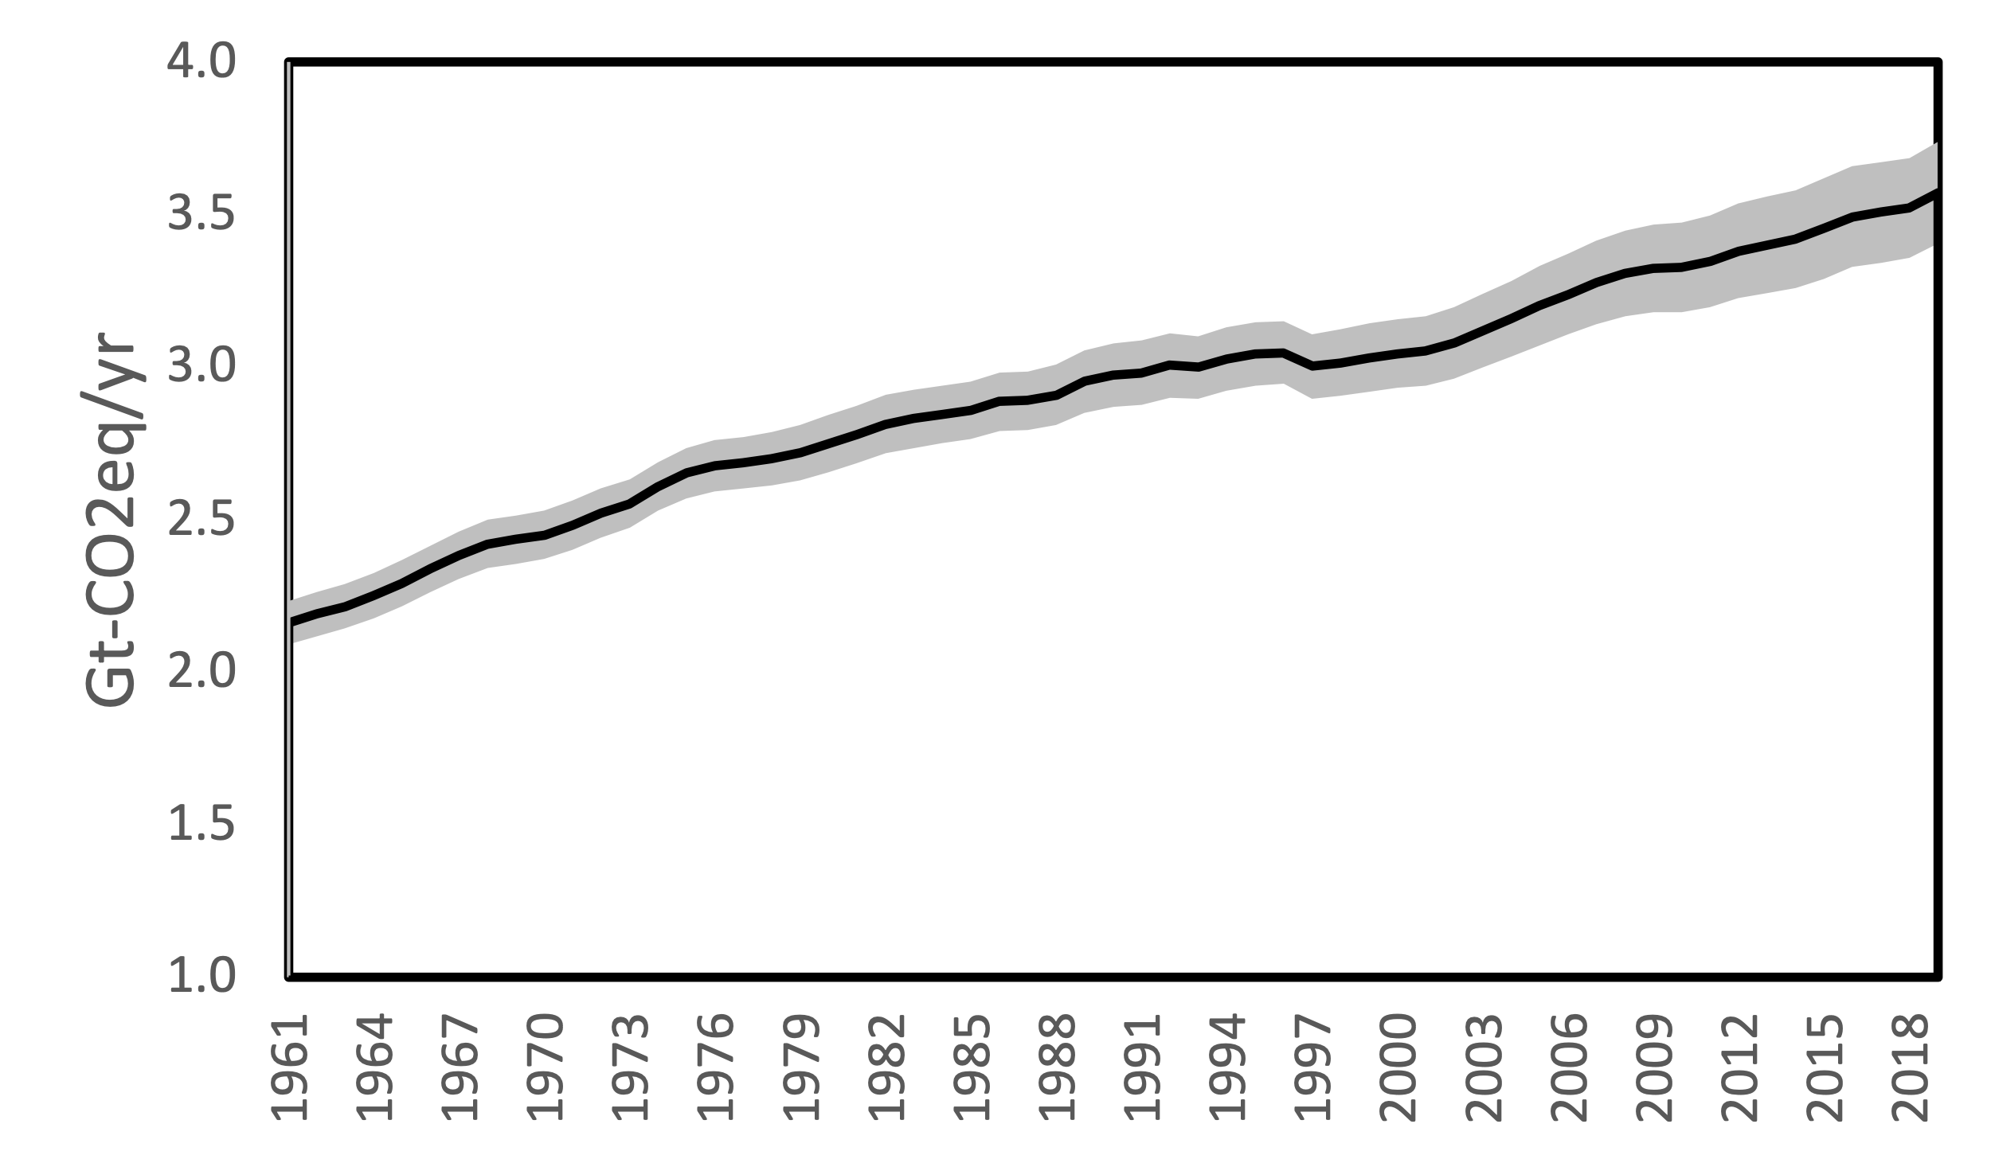

Figure 1. Global methane emissions from enteric fermentation for 1961-2019. Calculated from FAOSTAT animal census data and IPCC 2019 emission factors.

The largest contribution of enteric methane emissions (1.19 Gt-CO2eq) comes from livestock in Asia. Having increases in dairy cattle as well as non-dairy cattle populations in recent years have contributed to the growth in enteric methane in this region. It is likely that the rising demands for milk and meat by increasing human populations will continue to lead to increasing emissions from livestock in Asia. The demand for animal products has also been increasing in the Middle East and Africa as all livestock categories and populations are on the rise for the last several decades. In fact, annual emissions of enteric methane from the Middle East and Africa have increased over 83% in the last thirty years.

Countries of the Organization for Economic Cooperation and Development (OECD90) are characterized by productive systems that are commercialized and tend to be highly productive. Their livestock populations have been relatively stable in the last ten years. While this may be the case, their emission factors for dairy and non-dairy cattle are some of the highest, contributing to their total enteric methane emissions of 0.54 Gt-CO2eq.

Figures 1.4 and 1.5 shows the global enteric methane emissions by animal category while Figure 1.6 shows emissions by region. The largest source of enteric methane comes from non-dairy cattle, making up 51% of total livestock emissions (or 1.76 Gt-CO2eq). Latin America, the Middle East, and Africa have seen the largest growth in the non-dairy cattle population since the early 2000s. In Latin America, beef cattle are primarily managed on grazing pastures and rangelands. Having few feedlots with grain feed makes Latin America the highest source of beef cattle enteric methane emissions

Figure 1.4 Enteric methane contributions by country, 1961-2019 (Tg-CH4) from top contributors (countries accounting for 99% of the total). Calculated from FAOSTAT animal census data and IPCC 2019 emission factors. UK & NI* = United Kingdom and Northern Ireland

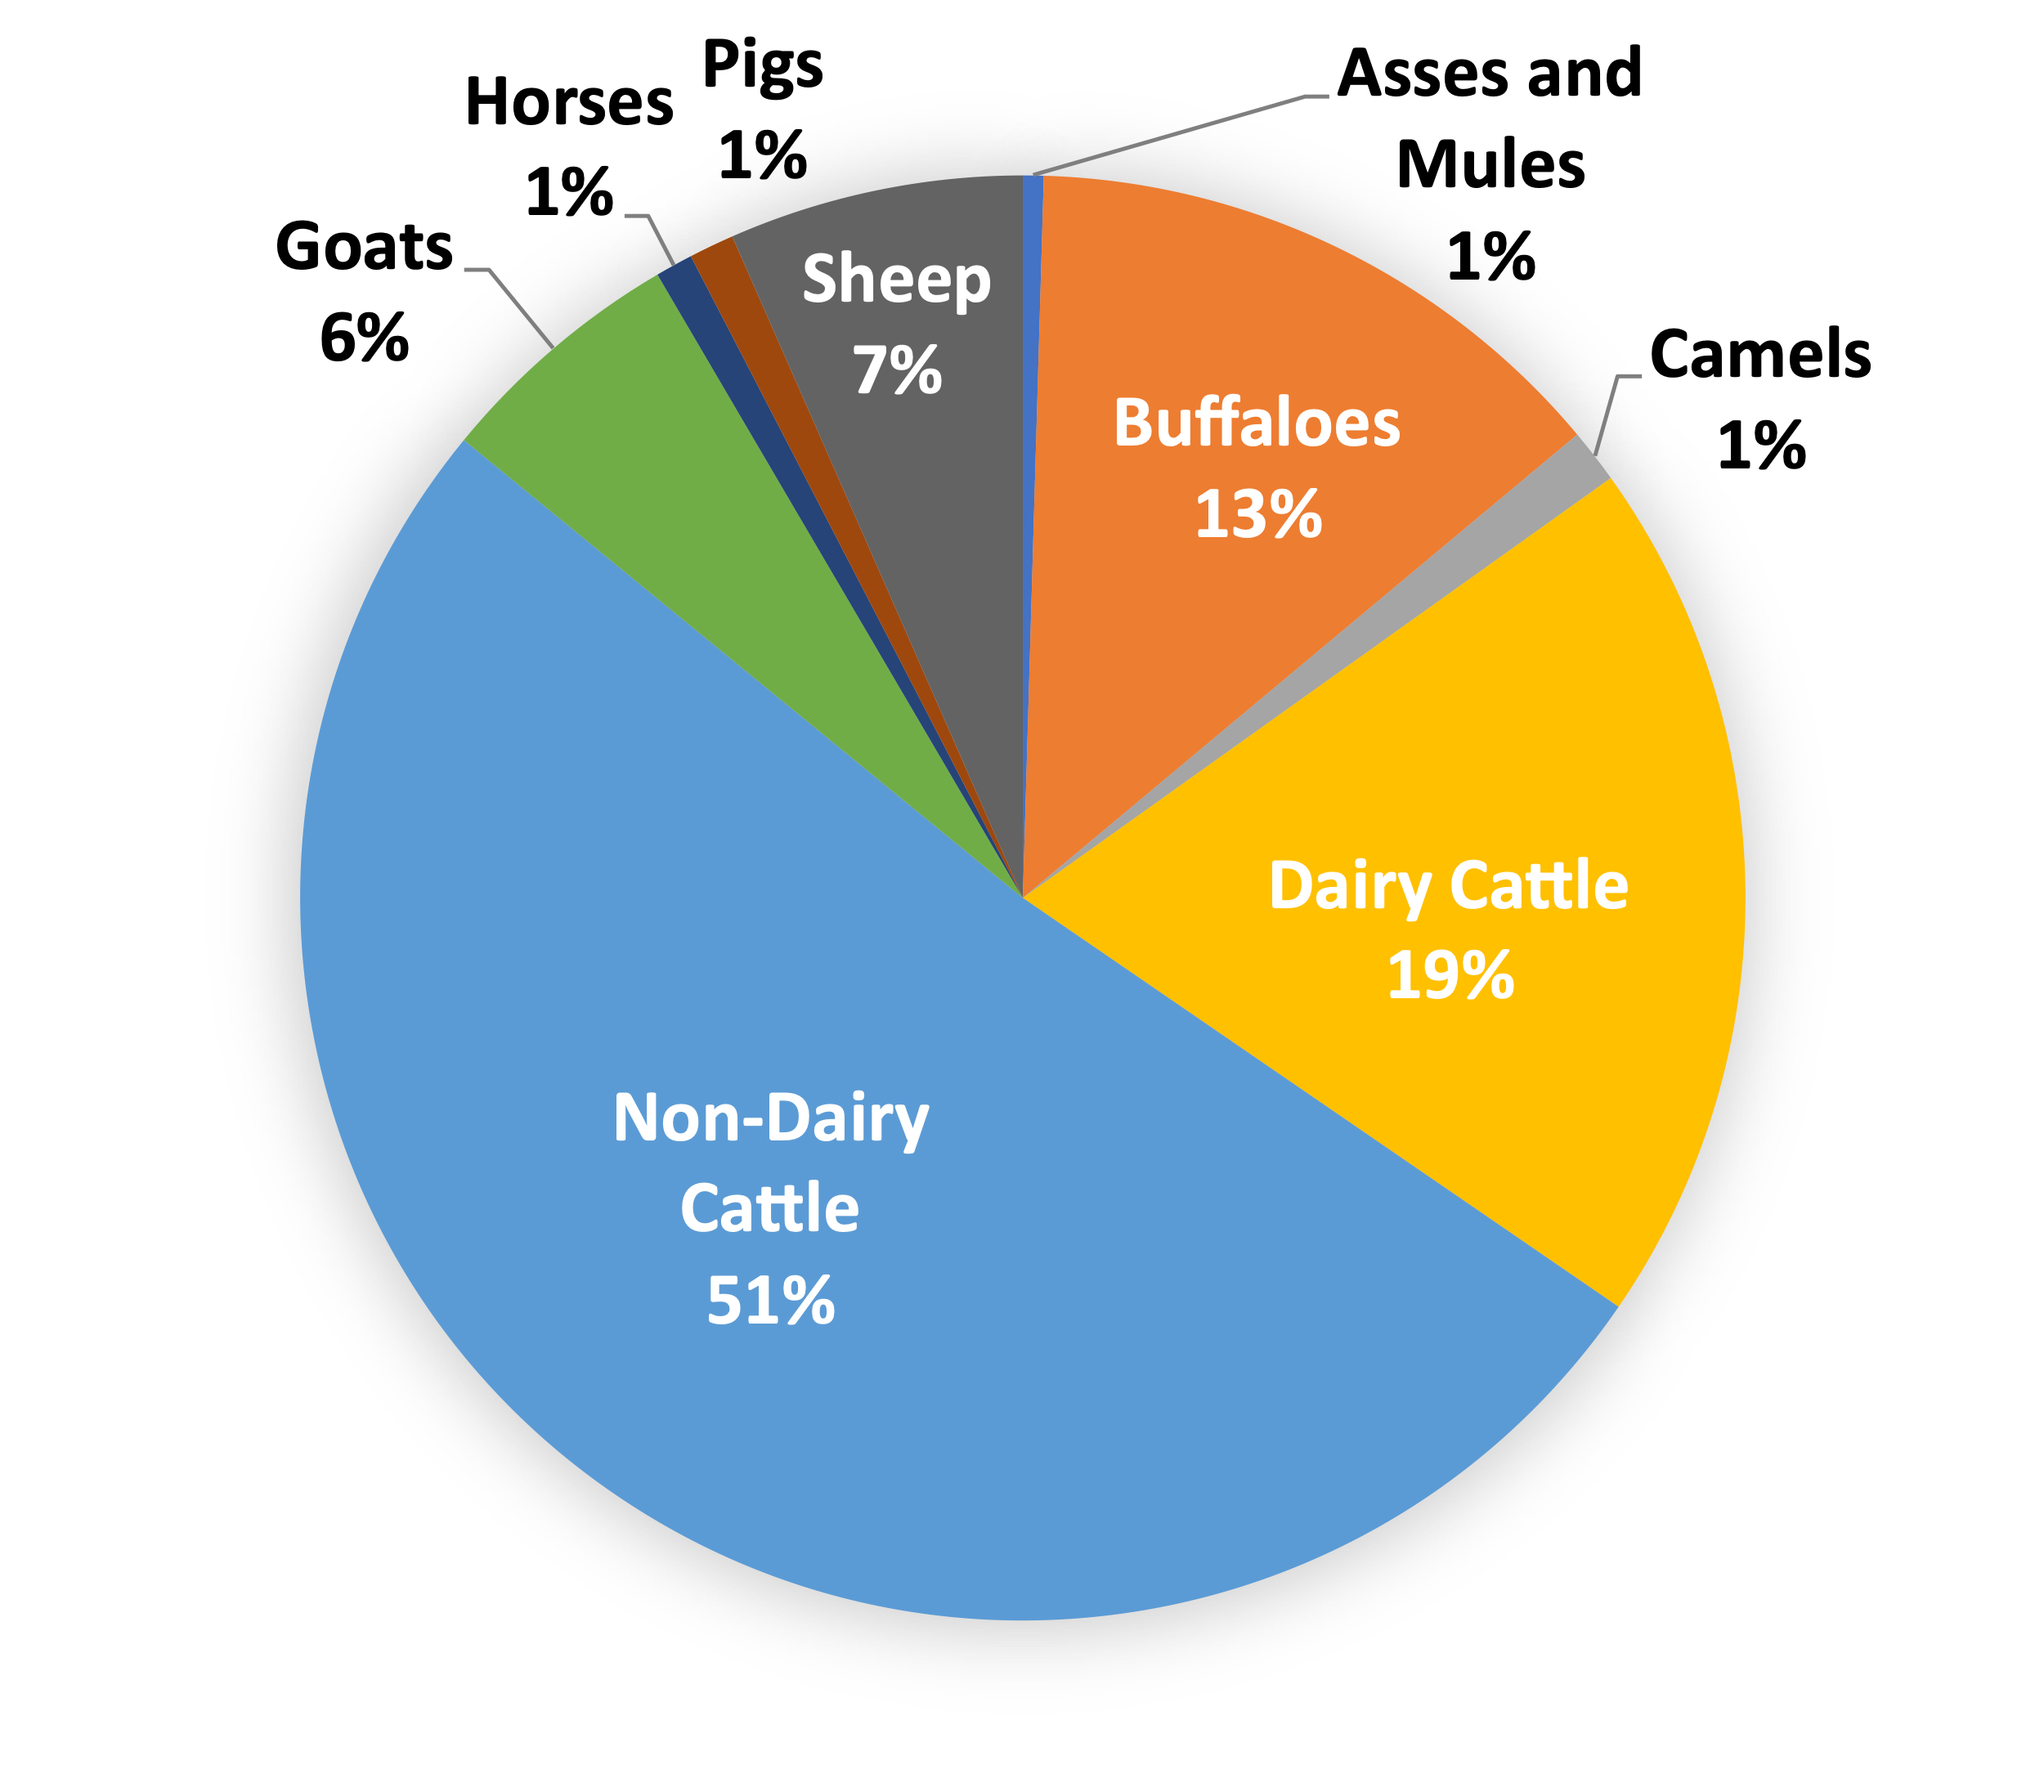

Figure 1.5 Fraction of global enteric methane emissions from each livestock category in 2014. Calculated from FAOSTAT animal census data and IPCC 2019 emission factors.

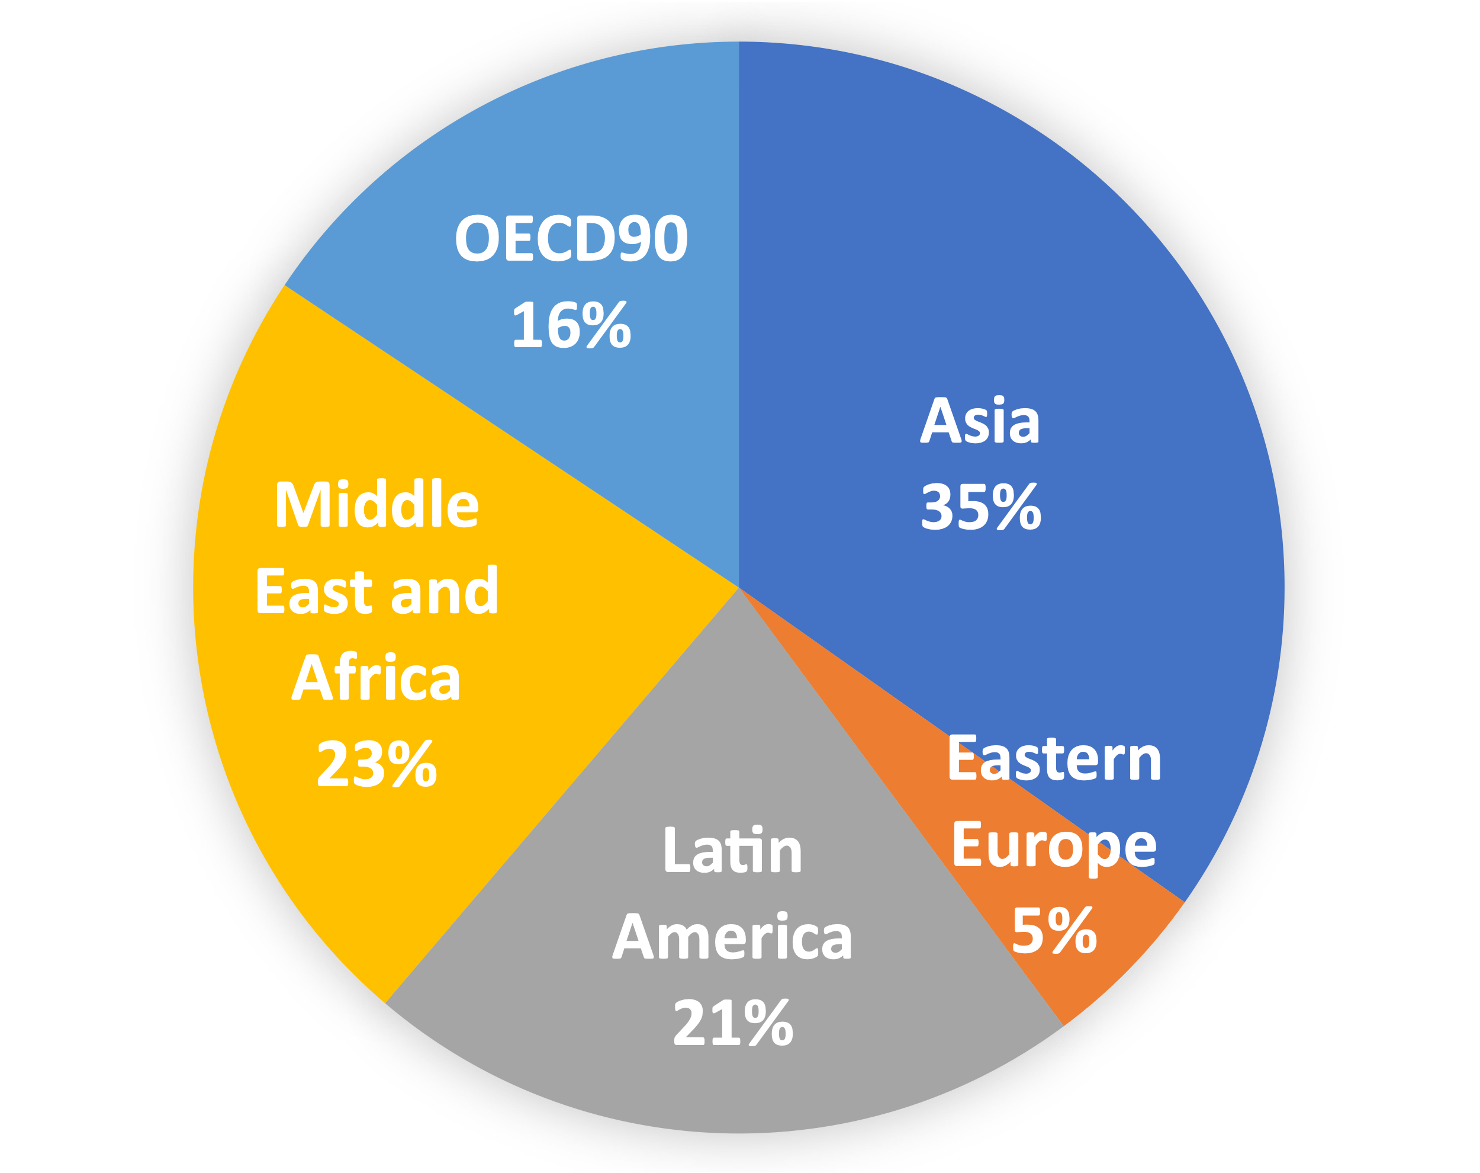

Figure 1.6 Fraction of global enteric methane emissions from each region in 2014. Calculated from FAOSTAT animal census data and IPCC 2019 emission factors.

Dairy cattle make up another 19% of total global enteric emissions (or 0.67 Gt-CO2eq), with most of the emissions originating in Asia and Africa. Asian dairy systems are becoming more commercialized with increasing numbers of grain-based feedlots. In contrast, African dairy systems are largely located on expansive pastures and forage areas. As a ruminant animal like cattle, buffalos produce substantial amounts of methane through their digestion process. Buffaloes, particularly those in Asia, make up a substantial source of enteric methane emissions 0.46 Gt-CO2eq). Asia contains the highest population of buffaloes on smallholder farms, where low-quality agricultural residuals usually make up their feed supply. Together, other ruminant animals (sheep and goats) and non-ruminant animals (horses, mules/asses, camels, pigs) also emit methane from their digestive tracts were estimated to emit another 0.54 Gt-CO2eq of methane annually.

#### Emission Intensity of Animal Products

Measuring emission intensity - emissions emitted per kilogram of product – such as milk and meat or protein allows greenhouse gas emissions to be compared in the context of production units and help better assess the impacts of livestock systems. Figure 1.7 shows differences in greenhouse emission intensities for livestock products (FAO, 2019). On average, the highest intensities are associated with products of ruminant animals. Meat production from buffaloes (404 kg CO2eq. per kg of protein), cattle (295 kg CO2eq. per kg of protein), and small ruminants (201 kg CO2eq. per kg of protein) were estimated as having higher emission intensities than milk products (87-148 kg CO2eq. per kg of protein). This variation is largely due to the feed management and enteric methane emissions of meat and milk producing animals.

Livestock product emission intensities also vary geographically. Regional differences tend to reflect different production systems and proportions of animal populations. Typically, higher income nations have more efficient production systems, reducing their emissions per kilogram of product (FAO, 2019). As a result, developed countries (e.g., the United States) exhibit the lowest emission intensities per kg milk ranging between 1.6 and 1.7 kg CO2eq/kg milk, while in developing countries (e.g., Gabon) the emission intensity for milk is relatively higher 2.0 and 9.0 kg CO2eq/kg milk (Opio et al., 2013). Generally, enteric fermentation is a dominant source of methane in developing regions while feed production and processing are the main sources of greenhouse gas emissions in developed regions. According to the FAO (2013) report on life-cycle assessment of ruminant supply chain, emission intensities of the milk production vary from 1.6 kilogram of carbon dioxide equivalents per kilogram of milk (kg CO2eq/kg milk) in Eastern and Western Europe to 9 kg CO2eq/kg milk (fat and protein corrected) in sub-Saharan Africa (Opio et al., 2013). Knowing the source of the emission intensities in different regions allows for more targeted approaches to identifying areas for improvement.

Figure 1. Emission intensities for livestock products as modeled in GLEAM 2. Source: FAO (2019).

#### Conventional Animal Feed Diets

Livestock feed composition consists of many different ingredients depending on factors such as the type of animal, its nutritional needs in its stage in life, production system type, and availability of feed in different regions. Feeding regimes can also be reflections of cultural preferences and can be constrained by resource availability (MacLeod et al., 2015). Less developed nations may not have the resources to grow and feed livestock in ways that wealthier countries do. Climatological variations and seasonal changes also affect feed production at the local level resulting in feeds not available locally needing to be imported (Birhan et al., 2014). Economic factors determining production costs and market prices also play roles in livestock feed options around the world (Lawrence et al., 2008).

Table 1.1 lists typical feeds utilized around the world for dairy cattle (Opio et al., 2013). In general, broad feed categories can be broken into roughages, by-products, and concentrates. Roughages are bulkier plant-based forages. The high fiber content and fibrous carbohydrates of roughages are slower to pass through the digestive system and require more energy to digest. As a result, they also tend to be associated with high methane emissions in ruminant animals. Non-ruminant animals like pigs and chickens have limited capacity to digest plant-materials, utilization of roughages is low among non-ruminant animals. Enteric methane emissions decrease with the processing of forages since grinding, chopping, and pelleting reduce energy expended to degrade and ferment the high fibrous cellulose (Le Liboux and Peyraud, 1999).

As Table 1.1 indicates, the utilization of different conventional feed ingredients varies among regions. In the United States, legumes and silage tend to be the dominant roughage ingredient (30.6% of diet) with supplements of grains (22.8% of diet) for dairy cattle (Opio et al., 2013). In contrast to the United States, countries like India in South Asia do not use many legumes and silage. Their dairy cattle primarily digest crop residues (60.1% of diet) and rarely receive high nutrient supplements (<6% of diet). This variation is indicative of the underlying agricultural preferences and the limited applicability of certain dietary regimes.

Other conventional feeds used around the world are the by-products of agricultural and industrial production. Well-known by-products include crop residues, oils and seeds from the production processes of the biofuel and distilling industries (Johnson et al., 2002). Some of these by-product feeds provide a significant source of protein for livestock that consume low-quality roughages. They are also highly digestible and improve ruminal fermentation (Moss et al., 2000). Because they are generally considered un-edible for human consumption, by-product feeds also provide opportunities for lower feed costs. Many by-products overlap in classification with concentrates. The variation in by-products by region is a main factor determining their use in animal diets.

As global livestock diets shift with market values and dissemination of knowledge on animal science, the production of feeds have also shifted (Figure 1.8). Greater understanding of animal nutrition paved the way for developing a holistic balanced diet that benefited the animal’s health and productivity. While prior livestock feed was forages and various oilseed cakes, formulated feeds considering protein and fiber levels standardized regimes. Now, over 900 ingredients make up an abundance of feed recipes (Gro-Intelligence, 2017). Predominately, corn production has outpaced all other ingredients, mainly because of the large populations of chickens who consume corn. Other widely produced ingredients extend to soybean products, wheat, and barley. Since 2010, global feed use has been over 1 billion metric tons per year (Figure 1.8). To meet the growing demand of animal meat and milk products, future feed production will likely increase to meet demand and find cheaper alternatives to meet animal nutrient and energy needs.

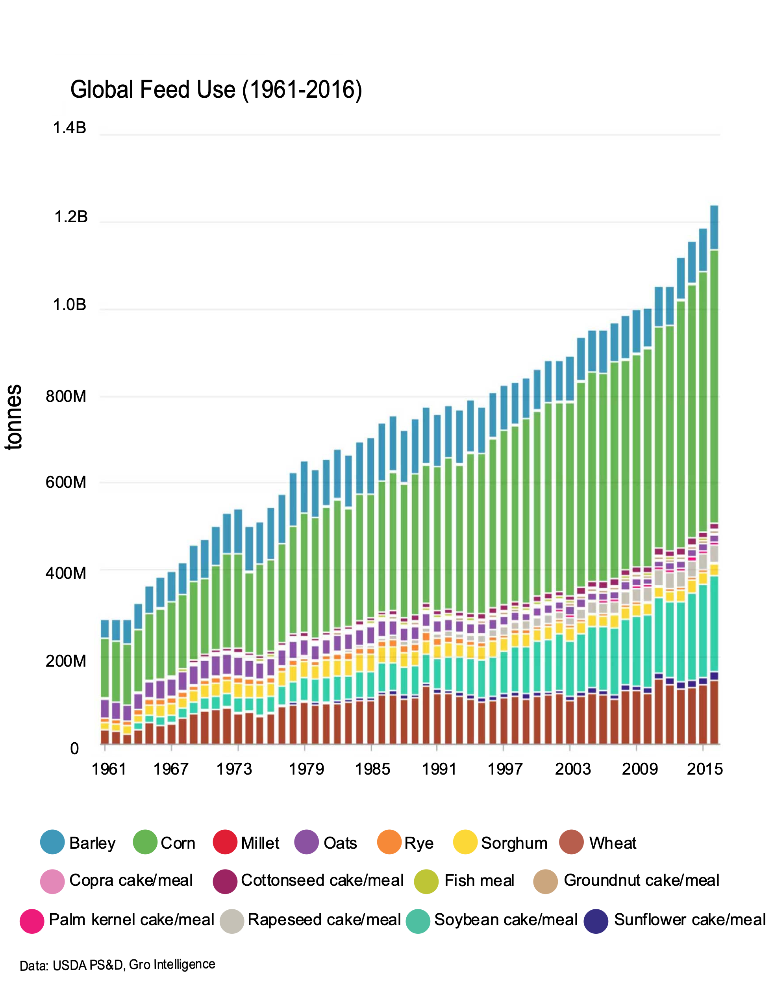

Figure 1. Annual distribution of global feed use. Source: Gro-Intelligence (2017

Table .1 Regional averages of dairy and beef cattle feed compositions (% of diet). Source: GLEAM based on input data from literature, national inventory reports, expert knowledge, and databases (Opio et al., 2013).

|  |  |  |  |  |  |  |  |  |  |  |
| --- | --- | --- | --- | --- | --- | --- | --- | --- | --- | --- |
|  | **Dairy Cow Feed Ration, Regional Averages (Percentages)** | | | | | | | | | |
|  | N. America | Russian Federation | W. Europe | E. Europe | NENA | E & SE Asia | Oceania | South Asia | LAC | SSA |
| Fresh Grass | 14.4 | 23.8 | 33.2 | 22.5 | 41.4 | 22.4 | 68.3 | 10.7 | 54.9 | 56.8 |
| Hay | 17.0 | 23.8 | 16.6 | 22.8 | 17.8 | 19.2 | 5.6 | 14.2 | 15.4 | 18.1 |
| Legumes and Silage | 30.6 | 34.3 | 22.6 | 33.2 | 0.3 | 2.7 | 10.4 | --- | --- | --- |
| Crop Residues | --- | 1.8 | 2.5 | 1.8 | 31.7 | 38.4 | --- | 60.1 | 8.7 | 17 |
| Sugarcane Tops | --- | --- | --- | --- | 1.6 | 6.0 | --- | 3.5 | 2.6 | 1.9 |
| Leaves | --- | --- | --- | --- | 3.6 | 2.3 | --- | 6.1 | 6.5 | 3.0 |
| Bran | 4.4 | 2.9 | 2 | 3 | 0.6 | 0.5 | 2.5 | 0.2 | 0.4 | 0.1 |
| Oilseed Meals | 6.4 | 4.6 | 8.5 | 5.7 | 2.3 | 6.7 | 1.3 | 5.2 | 6.4 | 3.1 |
| Wet Distillers Grains | 4.3 | --- | --- | --- | --- | --- | --- | --- | --- | --- |
| Grains | 22.8 | 7.2 | 13.2 | 9.1 | 0.2 | 7.2 | 11.8 | --- | 4.9 | 0.1 |
| Molasses | --- | --- | 0.1 | --- | 0.5 | --- | --- | --- | 0.1 | 0.1 |
| Pulp | --- | 1.8 | 1.3 | 1.8 | --- | --- | --- | --- | --- | --- |
|  |  |  |  |  |  |  |  |  |  |  |
|  |  |  |  |  |  |  |  |  |  |  |
|  | **Beef Cattle Feed Ration, Regional Averages (Percentages)** | | | | | | | | | |
|  | N. America | Russian Federation | W. Europe | E. Europe | NENA | E & SE Asia | Oceania | South Asia | LAC | SSA |
| Fresh Grass | 35.2 | --- | 36.0 | 21.0 | 24.9 | 23.6 | 63.5 | 8.0 | 65.1 | 61.1 |
| Hay | 39.4 | --- | 14.8 | 21.9 | 36.7 | 18.7 | 6.8 | 12.5 | 9.4 | 12.6 |
| Legumes and Silage | 7.8 | --- | 23.1 | 32.3 | 2.1 | 0.7 | 10.7 | --- | --- | --- |
| Crop Residues | --- | --- | 3.8 | 2.1 | 24.2 | 46.2 | --- | 68 | 10.2 | 19.4 |
| Sugarcane Tops | --- | --- | --- | --- | 0.1 | 0.8 | --- | 3.6 | 2.5 | 3.7 |
| Leaves | --- | --- | --- | --- | 9.2 | 2.8 | --- | 5.9 | 4.1 | 1.6 |
| Bran | 0.9 | --- | 1.7 | 3.5 | 0.3 | 0.2 | 3.8 | 0.1 | 0.1 | --- |
| Oilseed Meals | 0.6 | --- | 7.6 | 6.6 | 1.9 | 2.7 | 1.5 | 1.9 | 3.9 | 1.4 |
| Wet Distillers Grains | 1.0 | --- | --- | --- | --- | --- | --- | --- | --- | --- |
| Grains | 15.1 | --- | 10.6 | 10.5 | 0.6 | 4.2 | 13.7 | --- | 4.7 | 0.1 |
| Molasses | --- | --- | 0.7 | --- | --- | --- | --- | --- | --- | --- |
| Pulp | --- | --- | 1.7 | 2.1 | --- | --- | --- | --- | --- | --- |

#### Strategies to Reduce Methane from Enteric Fermentation

Many strategies to reduce methane emissions from livestock have been studied and are in various forms and stages of adoption around the world (Hristov et al., 2013 and Gerber et al., 2013). The focus of some of these approaches include feed additives, manipulation of rumen microbes, feed composition management, or feeding management. Feed additives and specialty feeds include inhibitors, electron receptors, ionophores, plant bioactive compounds, and exogenous enzymes. Incorporation of lipids (example, by-product vegetable oils) and direct-fed microbials have been used as dietary strategies. Feeding strategies such as inclusion of concentrates, improving forage quality, grazing management, and processing feed (chopping, grinding, ensiling) as well as precision feeding and feeding have been studied for their methane mitigation potentials. Precision feed formulation and feeding could promote efficient resource use while ensuring that the animal receives the optimum diet.

Feeding lipids, usually comprising of agro-industrial by-products such as meals and distillers’ grains, offer mitigation opportunities by replacing dietary carbohydrates and reduced dry matter intake. Concentrates are high in energy and digestible nutrients, including fats and cereal grains. The use of concentrates as a supplement to roughages and forages reduces the overall fiber intake and pH level of the rumen (Hook et al., 2011). In effect, concentrates suppress the level of methane production from enteric fermentation (Satyanagalakshmi et al., 2015; Beauchemin et al., 2008). Depending on a variety of factors including type and fiber digestibility, level of processing, quantity, and quality of the basal forage, incorporating concentrates could decrease methane. The costs, availability, ease of use, effects on animal productivity, and social acceptance are some of the considerations for determining the feasibility of these options.

Feeding high-quality (low fiber, easily digestible, high soluble carbohydrates) forages also present methane mitigation opportunities. Such forages include C3 grasses, brassicas, and legumes (Banik et al., 2013). Compared to C4 grasses, livestock fed C3 grasses were found to emit 17% less methane per unit organic matter intake and warm weather legumes, 20%, less (Archimede et al., 2011). Forage quality has been shown to be growth-stage dependent thus, grazing management might help ensure optimum maturity of forages is achieved (Hristov et al., 2013). Improved feed quality usually leads to increased individual animal performance and associated economic co-benefits thereby serving as a good mitigation option for producer.

Feed processing affects digestibility, energy maintenance, and passage rate resulting in improved feed efficiency and reduced methane emissions (Firkins et al, 2001; Yang et al., 2012). Increased digestibility was reported for steam-flaked corn compared to dry corn and linked to reduced methane emissions (Firkins et al., 2001). Precision processing of barley through roller settings adjustment for example, increased feed efficiency in feedlot cattle and resulted in feed savings of 163 kg per animal compared to the conventional (Yang et al., 2012). Chopping and pelleting forage can reduce methane (Le Liboux and Peyraud, 1999).

Ensiling forage reduces methanogenesis as ensiled forage is partially fermented. Grass silage is usually harvested at the late maturity stage and has low levels of digestible organic matter. In comparison, maize silage was found to have higher levels of starch, which favor propionate production (Banik et al., 2013). Analyses show whole-crop cereal sillages in ruminant diets decrease methane production (Hristov et al., 2013). Hassanat et al., (2013) reported that feeding a diet containing more digestible corn silage resulted in a reduction in methane production but increases in manure emissions during storage were observed.

Advancements are being reported in the use of feed additives as ways of reducing enteric methane emissions through dietary manipulation. Belanche et al. (2020) reported from on-farm trials and meta-analysis of long-term (greater than 4 weeks) *in vivo* studies that a proprietary blend of essential oils reduced methane production by up to 10% when given to dairy cows. Increases of 4.4%, 3.6% and 4.1% were reported for feed efficiency, milk yield, and fat protein corrected milk, respectively. The supplemented dose was 1 g/d for each cow.

#### Summary

*Improved cattle feed quality* is defined as set of feeding strategies that lower enteric methane emissions through the change the composition and/or nutrient intake of the animal. Project Drawdown considers three feeding strategies to replace conventional low-digestible rations. The strategies include *high-quality forages* (low fiber, easily digestible, high soluble carbohydrates such as legumes and cool season annuals), *feed additives* (certified methane reducing compounds), and *feed supplements* (concentrates and grains). Several enteric methane mitigation strategies have been extensively explored through experimental studies and metanalysis spanning decades and are in various forms of adoption. The most promising, feed additives reduced methane by about 30% without reducing animal productivity or producing side effects on rumen fermentation. Feeds such as high-quality forage and ensiled whole crops also offer mitigation opportunities. Improved individual animal productivity from high-quality forage will be economically advantageous. Ensiling whole crops would also provide added financial benefits as the need for more costly cereals are reduced.

## Adoption Path

### Current Adoption

Owing to the heterogeneity of animal diets and production systems and practices as well as different levels of reporting worldwide, data on the adoption of the feeding strategies defined under the improved livestock feed quality solution was scarce. Even within a single farm, what might be a considered as an improved feed quality for a young heifer could greatly differ from an improved diet of older lactating dairy cow. Due to scarcity in data, reported mitigation from a specific farming system in a country were extrapolated to other countries in the same region for similar production systems.

Using data derived from Mottet et al. (2017), it was estimated that the global livestock sector ingested 6.0 billion tonnes of dry matter feed in 2010. Large ruminants alone ingested 72% of that, or 4.3 billion tonnes and the primary component (88%) of this diet consisted of roughages (see Figure 1.9). Roughages ranged from low-quality grasses and hay to silage, crop residues, and tree fodder. Although the distinction was not made within the originally sourced data, we applied a global average of the percentages seen in Table 1.1 to estimate that 13% of the roughages are from legumes and silages, ingredients we consider to be a part of the Drawdown solution. In addition to roughages, another 9% of the dry matter consumed consisted of grains; cereal grains grown for livestock consumption and brans spent from the brewing and biofuel industry. Only 2% of dry matter intake were processed into soybean and oilseed cakes. An additional 1% were considered other non-human-edible ingredients (corn gluten, pulp, molasses, fish meal, synthetic amino acids, and lime).

Rations varied between developed OECD90 countries and non-OECD90 countries. Notably, the feed dry matter intake per kilogram of protein produced was substantially lower in the developed world. In grazing, mixed, and feedlot systems in the non-OECD countries, 195, 171, and 99 kg of feed were required to produce 1 kg of protein, respectively according to feed conversion factors reported in Mottet et al. (2017). These production systems were 1.6 to 3.2 times less efficient than their counterparts in OECD countries requiring a higher number of animals to be raised to meet the same level of protein demand. Nearly 0.8 billion tonnes of dry matter feed were reportedly consumed (19% of the global intake) by the OECD90 region and 3.5 billion tonnes by non-OECD90 annually. Another key difference between the developed and the developing world was the use of concentrates and other supplements. About 24% of cattle feed were from grains, concentrate, and other supplemental feed in the OECD90 region, and only 9% in non-OECD90 regions.

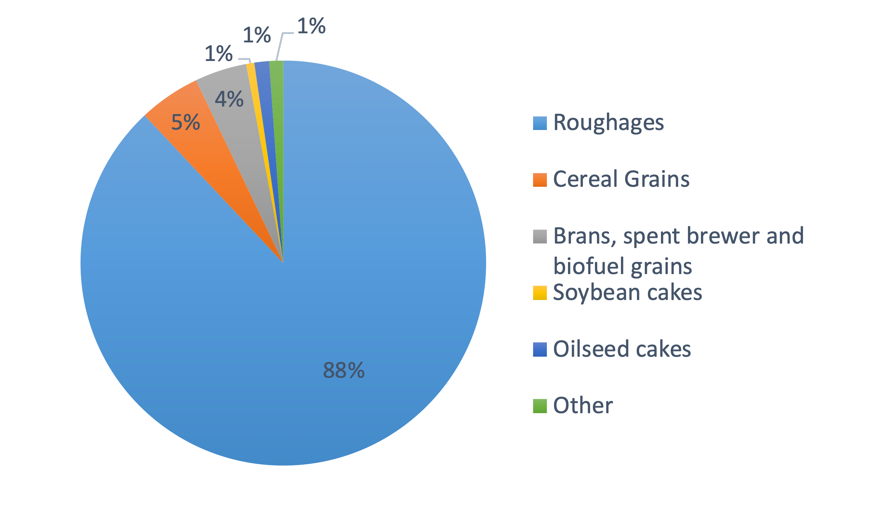

Figure 1. Global dry matter intake by type of ingredient for cattle. Data sourced from Mottet et al. (2017).

Figure 1.10 Fraction of dry matter intake by ingredient for cattle feedlots, mixed, and grazing systems in OECD90 and non-OECD90 regions. Data sourced from Mottet et al. (2017).

There were also substantial differences in rations among the three types of cattle production systems: feedlots, mixed farming, and grazing. Feedlots are market-oriented operations that target diets for weight gain and increased meat production. Diets are optimized with high energy and protein-rich ingredients which usually have low enteric methane production levels making them ideal for an improved feed quality solution using grain and concentrate supplementation. Mixed farming systems are generally crop-producing farms that also contain livestock production. Dry matter feed comes primarily from roughages out in the pasture, but also from crop by-products and residues. In a similar fashion, grazing systems are largely dominated by cattle feeding off pastures and rangelands, where the majority of their diet is roughages. Both grazing and mixed systems are ideal for implementing the growth of high-quality forages supplemented with low amounts of concentrated for animal feed.

When all dry matter intake is converted into kilograms of protein product using unique feed conversion factors for each production system (conversion factors found in Mottet et al. (2017)), we are able to estimate the amount of protein produced from high quality feeds. The current global adoption of the solution is 13.2 billion kilograms of protein (or 13.2 megatonnes protein). Of 43.9 billion kilograms of protein sourced from bovine meat and milk to meet the human demand for food, the proposed improved feed quality solution is estimated to contribute 22% of all dry matter intake consumed. Practical considerations such as the need for balanced diets in all regions and production systems year-round, might mean that not all cattle-sourced protein can be generated from the improved feed quality solution at all time. Some diets may include some low-quality forages.

### Trends to Accelerate Adoption

The spatial distribution and speed of adoption of the proposed improved feed quality solution for cattle will depend on key pressures and drivers that exert change on crop-livestock systems. The many drivers operate at a variety of levels – at the global level, regional level, and individual farm level. The global human population is projected to double to nearly 2 billion by 2050. Additionally, increasing incomes and urbanization (with increased access to markets) within developing countries, and shifting of dietary preferences to higher livestock-sourced foods are being predicted. The rise in population, especially within urban settings, is expected to put a strain on the available natural resources such as fresh water supply. Despite the challenge of increasing pressured on natural resources, the demand for livestock products is expected to rise significantly in the coming decades. To meet the demand, livestock production is projected to increase.

Technological changes are also key drivers of agricultural growth and livestock productivity. Applications of improved technologies and investments in agriculture have seen increasing trends globally. For example, modest investments to enhance irrigation systems in developing countries have achieved significant gains in crop productivity. This improved crop productivity supports local food security and provides high quality residues for livestock feed. Advancements in animal science can also accelerate adoption of the solutions. Improving genetics and breeding cows with rumen microbiomes conducive for lowering enteric methane emissions while accelerate animal productivity are possible.

Lastly, extension services aiming to provide knowledge based on sound science to strengthen agricultural communities and the well-being of families will be needed. Local extension offices address public needs and concerns by identifying practical solutions (such as the improved feed quality solution) and encouraging change. By building trust and serving the community, extension providers will be able to help break set standards and what “have always been done” and motivate adoption of replacement practices and technologies. An integrative approach that involves creating positive changes through non-formal education on other areas of the value chain such as food safety and waste management will be beneficial.

### Barriers to Adoption

Generally, feed costs account for majority (about 60%) of the expenditure of livestock production systems. Influencers on the adoption of improved cattle feed quality by cattle producers are therefore profitability (lower input costs with increased revenue), lowering risks and addressing of productivity challenges. Due to the variations in agroecological regions and production systems, no single feed solution will be applicable for all production systems. While some solutions may be more suited to one region than another, individual systems will also need to adjust and monitor their feed strategies to best fit their animal distributions (age, breed, phase in lactation, etc.) and land (soil fertility, water supply, etc.). A lack of incentive to change from “what has always been done” could prohibit adoption.

Adoption new feed will require the technical know-how to formulate and implement nutritionally balanced rations which would be challenging to most small-holders (FAO and NZAGRC, 2017as). Having guidance through farmer assistance and research extension programs will help provide up-to-date information and alleviate the burden on the farmer. However, access to such programs is not equally and readily available to all farmers. As most livestock production systems are small-scale operations, adoption to new and improved livestock practices may be a slow process. For a producer to switch practices, the improved practice must show improvements to the animal’s production and the producer’s profitability. A producer would be more reluctant to adopt new diets that will compromise their overall profits (Grainger et al., 2009). However, the cost-effectiveness might not be immediately apparent as upfront feed costs take time to turn around a profit from the animal’s improved performance. Implementing a new feeding strategy will take planning on the part of the producer.

In developing nations, feed resources may not be readily available in sufficient quantities. Fluctuating weather conditions and seasonal changes make it difficult to rely on rain-fed feed production. While producers could conserve feeds for the dry season, provisions for feed preservation are an uncommon practice among small-scale operations in developing nations. The lack of technical skills in treatment of residues and fears of ammonia poisoning perpetuate the current low adoption of feed conservation.

Beyond seasonal production constraints, livestock systems in developing nations are characterized by systemic barriers. Barriers include poor infrastructure and storage facilities, in addition to inadequate technology and machinery. All of which will require an expensive upfront cost. Further, rural communities have limited market opportunities to purchase high-quality feed supplements and additives. Adoption of alternative feeds requires the expansion of market selections.

Not all feedstuff is grown on-farm. Global trade and volatility of fuel, feed, and fertilizer prices make it difficult to predict production changes. What might be cheaper feed one year may not necessarily be as inexpensive the following year. So, keeping up with a specific high-quality feeding regimen that is cost-efficient may not be possible and farmers may elect to switch to lower-quality feeds if they are more economical.

Not all feeds are grown on-farms. Global trade and volatility of fuel, feed, and fertilizer prices make it difficult to predict production changes. What might be cheaper feed one year may not necessarily be as inexpensive the following year. Therefore, keeping up with a specific high-quality feeding regimen based on purchased feeds that is cost-effective may not be possible and farmers may elect to switch to lower-quality feeds if they are more economical.

In developed nations, such as the United States, new premium feed additives must go through extensive trial phases and be approved for use at the federal level. It could take months to years for a new feed additive to be approved for sale. Even after gaining approval, educating and convincing producers of the benefits of switching to a new feeding strategy will require great efforts from the manufacturers.

Animal health and genetics may also be a barrier to adoption. Many animal health problems result from poor living conditions, climatic stressors, and susceptibility to disease especially in low-income regions. Poor animal health reduces a cow’s weight gain, reproductive performance, and milk production. When given high-quality feed, the digestibility and enteric methane mitigation opportunity might still be limited by the health of the animal. Genetics and breed will also play a role in the methane mitigation capacity since some breeds of cattle are more tolerant and better suited to alternative feed strategies than others.

### Adoption Potential

There is considerable adoption potential in developing countries as they will be the driving force for increased demand for livestock products. Yet, few estimates of adoption rates are few and hard to find in the literature, likely due to the heterogeneity of cattle operations. Thornton and Herrero (2010) provide the most comprehensive adoption potential for improved pastures and intensifying ruminant diets for mixed and rangeland production systems found in the tropics. Their estimates indicate the implementation of high digestible forages in Central and South America can mitigate 29.8 Mt CO2-eq at a plausible adoption rate (1.3% per year, up to 30% in 2030). At a 100% adoption, 44.5 Mt CO2-eq can be mitigated by improved pastures in Central and South America by 2030. Although they did not extrapolate to a global level, adoption of improved forages has the potential to be widely implemented on a global basis owing to the magnitude of cattle rangeland.

Thornton and Herrero (2010) also reviewed the potential for diet intensification using stover from crops and grain supplementation. In mixed crop-cattle systems, crops provide a dual-purpose. They are grown for sale on the market and leftover residues used as cattle feed. This animal diet solution could be applicable across global rain-fed and irrigated crop systems where cattle numbers are projected to increase. Modelled in Sub-Saharan Africa and South Asia, stover use can be adopted at a 1% per year rate up to 23% in 2030 for a plausible adoption scenario. At this rate a total mitigation of 14.2 Mt CO2-eq could be reached. Nonetheless, adoption could be as high as 43%, which is currently observed in West African mixed cattle systems. At a 100% adoption in Sub-Saharan Africa and South Asia, a maximum abatement of 61.6 Mt CO2-eq is possible by 2030.

Also modelled in Sub-Saharan Africa and South Asia was the use of grain supplementation. Thornton and Herrero (2010) assume a 1% per year adoption, up to 23% in 2030. They argue similar adoption rates are possible for agroforestry-based supplements as well. Although, they see adoption as most suitable for humid and temperature mixed systems, thus having a smaller domain than stover crops. Their calculations suggest 5.1 to 22.1 Mt CO2-eq mitigation is possible by 2030 using grain supplementation in tropical Sub-Saharan Africa and South Asia.

While Thornton and Herrero (2010) modelled each diet option separately for the tropics, they did not model all options in combination. Project Drawdown’s *improved feed quality* solution differs by modelling all options together at the production level and on a regional basis for a bottom-up approach to a global analysis.

## Advantages and disadvantages of Improved Feed Quality

### Arguments for Adoption

Increasing the quality of livestock feeds is an avenue for enhancing livelihoods by promoting environmental advantages, food security, and overall economic development through increased productivity. Increased productivity reduces the number of animals and resources needed to meet the high demand of animal products in wealthier nations. With lowered resource requirements for water, land, and labor, agricultural systems become more economically efficient and reduce their environmental impacts.

The feed solution will also improve human health by providing additional food security. Since animal-sourced foods are dense in essential nutrients and vitamins, a growth in production also provides valuable nutritional benefits in societies that are under-nourished. The enhanced nutrition is essential for cognitive development and proper immune-system functionality. Besides the increased animal-sourced foods, the mixed systems of crop and livestock production provides additional sustenance through increased crop yields.

Interventions to improve feed will support livestock farmers and their families by providing income and positive economic returns through increased milk and meat production. The cost-effectiveness of the solution is critical for supporting small-holder farmers whose revenue depends on the quantity and quality of their animal’s production.

### Adoption Burdens

While improved feed quality contains several advantages for adoption, there are potential environmental burdens to consider. The cattle protein value chain has been sources of environmental emissions and resource use concern. In addition to greenhouse gas emissions, land degradation, nutrient runoff, water and energy use, as well as mineral extraction are other indicators of negative impacts that have been attributed to the meat and milk the value chain. The analysis of the impact of improved feed quality on these factors is beyond the scope of this study however to ensure a more sustainable feed source, implementation of responsible farming practices is necessary. Nutrient optimization, conservation tillage, cover crops, and efficient grazing and manure management will need to be practiced producing sustainable animal-sourced products.

The improved feed solution will potentially give rise to socio-economic co-benefits such as increased productivity and food security as well as improved livelihoods from higher incomes. The solution may however insinuate continual production and potential over-consumption leading to potential waste generation with associated socio-economic burdens.

Furthermore, careful consideration must be made when choosing ingredients of the livestock feed rations. Feed that is raised for livestock is often misconceived as food that is being re-directed away from human use. While some ingredients could be edible for humans, most are not. Our livestock feed solution promotes the primary use of high-quality forages and agro-industrial by-products most of which are not suitable for human consumption.

### Similar Solutions

While Project Drawdown limits the *improved cattle feed quality* solution to high-quality forages, certified feed additives, and supplementation of concentrates and grains, there are other similar feed solutions that help address the reduction of enteric methane emissions. Here, we explore similar solutions that are still in development, but not yet adoptable.

*Rumen microbe inhibitors.* Methane emissions have been reportedly reduced by at least 50% with the use of compounds such as 2-bromo-ethane sulfonate, chloroform, and cyclodextrin which inhibited specific rumen microbes (Immig et al., 1996; Lila et al, 2004; Knight et al., 2011; Mitsumori et al., 2011). However, the microbes have been shown to adapt over time, reducing the long-term effects of these inhibitors. Bromochloromethane, whose inhibitory effects persisted (Abecia et al., 2012), is a Class 1 ozone depleting compound according to the US Environmental Protection Agency. Results of the efficacy of exogenous enzymes have been conflicting with some reporting increases in methane emissions with increases in animal productivity (Chung et al., 2012). Technologies for manipulating rumen microbes such as defaunation and vaccinations are still in development.

The compound, 3-nitrooxypropanol (3-NOP), is a highly specific inhibitor of the enzyme in the rumen microbiome responsible for catalyzing the last step of the reaction that forms methane. Several studies using 3-NOP as additive have reported reduction in ruminant methane emissions between 24% and 60% while a few (Reynolds et al., 2014) saw relatively low reductions at about 7% to 10%. Romero-Perez et al. (2015) reported 59.5% reduction in methane in heifers fed total mix ration (60% forage, dry matter basis) with no effect on volatile fatty acids. Reductions of 60% in dairy (Haisan et al., 2014) and 24% in sheep respiration chambers (Martinez-Fernandez et al., 2013) have also been observed. No adaptations were seen in cattle and methane reduction effects were reversed when the 3-NOP additive was discontinued (Haisan et al., 2014; Romero-Perez et al. 2015). Van Wesemael (2019) did not observe differences in effectiveness of the additive incorporated into concentrate pellet or mixed with the basal forage. From meta-analyses, Dijkstra et al. (2018) and Van Gastelen et al., (2020) reported that the effectiveness of NOP at mitigating methane emissions increased with dosage, decreased with dietary fiber content, and was higher in dairy cattle than in beef cattle. Hristov et al. (2015) and Diun et al. (2016), 3-NOP have reported that when fed at 40 to 80 mg/kg and 60 mg/kg dry matter, respectively, reduced methane emissions by close to 30%. A similar concentration (60 mg/kg dry matter) reduced daily methane emission (26%), emission yield (27%), and emission intensity (29%) as found by Melgar et al. (2021). Furthermore, dry matter intake (DMI), feed efficiency, and energy-corrected milk yield, were not affected. Histrov et al. (2015) reported 80 higher weight gain in cows receiving 3-NOP. In terms of environmental impacts, enteric emission of carbon dioxide was not affected, while hydrogen emission increased 6-fold (Melgar et al., 2021). In a commercial scale trial involving 15,000 heads of feedlot cattle, 3-NOP reduced methane emissions in the ranges of 31%-80%. Finishing diets contained steam-flaked corn and the 3-NOP dose of 125 mg/kg feed ingredient.

*Nitrate supplementation.* Nitrate, an electron receptor, has shown positive results when used as supplementary feed in studies with up to 87% reduction in theoretical methane production potential in beef cattle and dairy cows (Hulshof at al., 2012; Olijhoek et al., 2016). Efficacy has been shown to be persistent (Lee and Beauchemin, 2014). Potential nitrite toxicity to the animal and negative environmental impacts from nitrate supplementation require more studies to inform better understanding on effects on the individual animal and whole-farm system (Lee and Beauchemin, 2014). Other well-studied electron receptors reduced methane emissions substantially from baseline levels, but long-term efficacy has not been well established (Hristov et al., 2013).

*Ionophore feed additives.* Ionophores (polyether carboxylic antibiotics) have been shown to improve feed efficiency and through that likely reduce methane emissions however, improved management practices overshadowed these effects (Duffield et al., 2008). Monensin, an ionopore, moderately mitigated methane emissions (5% reduction) in beef and dairy cattle fed high-grain or mixed grain-forage diets but not all-forage diet (Appuhamy et al., 2013; Hristov et al., 2013). Furthermore, although ionophores are widely used as anticoccidials, antibacterial, and growth promotants in ruminants, they are toxic to certain species and banned in the European Union.

*Plant bioactive compounds.* Tannins, saponins, and essential oils have varying mitigating effects (Goel and Makkar, 2012). Tannins and saponins have additional benefits including improving protein metabolism and reducing nitrogen loss in urine and feces however, when applied incorrectly, they might have negative effects such as impair rumen function and reduce animal productivity (Grainger et al., 2009; Patra, 2010; Goel and Makkar, 2012; Jayanegara et al., 2012). As a wide variety of these compounds exist with different modes of action. A harmonized system for studying the nature, levels in the various sources, and activity are needed (Grainger et al., 2009; Patra 2010; Jayanegara et al., 2012). More *in vivo* and long-term animal research are also needed to help better understand the anti-methanogenic effects. It will also be helpful in identifying tanniferous plants suitable for forage, appropriate inclusion concentrations and beneficial to enteric methane reduction (Waghorn, 2008; Grainger et al., 2009).

*Direct-fed microbials*. The use of direct-fed microbials have been common given their ability to promote rumen function. Probiotics and yeasts are the most studied in ruminant nutrition while bacterial probiotics have been more commonly reported in non-ruminants (Mahesh, 2021). By promoting rumen function, feed efficiency and consequently, animal productivity increased but the resulting effect on methane reduction has been conflicting and need to be further verified (Hristov et al., 2013; Vyas et al., 2014). Propionate precursors have been studied for their ability to decrease methane production in ruminal fluid. Newbold et al., 2005 studied 15 potential propionate precursors and metabolic intermediates *in-vitro* and discovered that 44% of hydrogen molecules that could be used for methane formation were captured. *In vivo* studies will help draw conclusions at the whole animal level.

*Proprietary supplementation of garlic-citrus additives.* Eger et al. (2018) reported that a proprietary combination of organosulfur compounds from garlic (*Allium sativum*) and flavonoids from bitter orange (*Citrus aurantium*) reduced methane emissions by 30% on the average while increasing milk yield by an average of 4%. No side effects on rumen fermentation were reported. The experiments were performed *ex-vivo* in fermenters. Ahmed et al. (2020) also reported from *in vitro* studies that methane reduced in digestible dry matter was 44% with treatment on grass and concentrate diets and efficacy increased with increasing concentrations. Vancken et al. (2019) reported reduced methane emissions of 38.3% and 20.7% in Jersey and Heifer cows, respectively fed the proprietary supplement without affecting milk quality and increasing milk yield. Roque at al. (2019) from in vivo studies observed this garlic-citrus additive as producing no significant differences in methane or carbon dioxide emissions between control and treatment groups and recommended further studies under various dietary regimens for feedlot cattle. In in vitro studies using sheep rumen fluid, Ahmed et al. (2020) reported promising results of methane reduction 22% and 54% (at 10% and 20% additive concentrations, respectively). The cost of this additive is $50 per cow per year (Zwick, 2017).

### Additional Benefits and Burdens

Here we consider the advantages and disadvantages of improved livestock feed quality with similar Project Drawdown solutions in the land and food sectors. Key considerations are defined as:

* *Yield Gains:*loss of yield “loss”,no impact “n/a”,1-9% low, 10-24% medium, 25%+ high.
* *First Cost:* Free is $0**,** Low is $1-100, Medium is $100-500, Expensive is $500+.
* *Net Profit Margin:*Low is $0-100/ha, Medium is $100-500, High is $500+.
* *Delayed Profit Period:*Short is 0-2, Mid is 3-6, Long is 6+

Table 1. Food Production Solutions Comparison: On-Farm Economic Impacts

|  | **Yield Gains** | **Startup Cost** | **Net Profit** | **Delayed Profit Period** |
| --- | --- | --- | --- | --- |
| Conventional cropping | n/a | n/a | Medium | n/a |
| Conventional grazing | n/a | n/a | Medium | n/a |
| Conservation agriculture | Low | Medium | High | Mid |
| Farmland restoration | High | Medium | Medium | Short |
| Farm water use efficiency | n/a | Expensive | Medium | Short |
| Improved rice | Loss | Free | High | Mid |
| Improved livestock feed quality | n/a | n/a | n/a | Short |
| Managed grazing | Medium | Medium | Medium | Mid |
| Multistrata agroforestry | n/a | Expensive | High | Long |
| Nutrient management | n/a | Free | Low | Short |
| Regenerative agriculture | Low | Medium | High | Mid |
| Silvopasture | Medium | Expensive | High | Long |
| System of Rice Intensification | High | Free | High | Mid |
| Tree intercropping | Low | Expensive | Medium | Long |
| Tropical staple tree crops | High | Expensive | High | Long |
| Women smallholders | High | Free | High | Short |

**On-Farm Impacts Social and Ecological Impacts**

* *Ecosystem Services:* subjective based on impacts on biodiversity, water quality, etc.
* *Social Justice Benefits:*Is solution Targeted to disadvantaged producers like smallholders and women, Relevant to them, or Not Applicable (n/a).
* *Climate Impacts per Hectare:*Low 0-3.7 t CO2-eq/ha/yr (0-1tC),Medium 3.8-11.0 t CO2-eq/yr (1-3 tC), High 11.1+ tCO2-eq/yr (3+tC).
* *Global Adoption Potential***:** Low 0-100Mha, Medium 101-500 Mha, High 500+ Mha

Table 1. Food Production Solutions Comparison: On-Farm Impacts Social and Ecological Impacts

|  | **Ecosystem Services** | **Social Justice Benefits** | **Climate Impact/ha** | **Global Adoption Potential** |
| --- | --- | --- | --- | --- |
| Conventional cropping | n/a | n/a | n/a | n/a |
| Conventional grazing | n/a | n/a | n/a | n/a |
| Conservation agriculture | Low | Relevant | Low | Medium |
| Farmland restoration | Medium | Relevant | Medium | Medium |
| Farm water use efficiency | Low | Relevant | Low | Medium |
| Improved rice | Medium | Relevant | High | Low-medium |
| Improved livestock feed quality | Low | Relevant | Low | n/a |
| Managed grazing | Low | Relevant | Low | Medium-high |
| Multistrata agroforestry | High | Relevant | High | Low |
| Nutrient management | Medium | Relevant | Low | High |
| Regenerative agriculture | Medium | Relevant | Low | Medium-high |
| Silvopasture | High | Relevant | High | Low-medium |
| System of Rice Intensification | Medium | Targeted | Medium | Low |
| Tree intercropping | High | Relevant | Medium | Medium |
| Tropical staple tree crops | Medium | Relevant | High | Low-medium |
| Women smallholders | n/a | Targeted | Low | Low |

# Methodology

## Introduction

Project Drawdown’s models are developed in Microsoft Excel using standard templates that allow easier integration since integration is critical to the bottom-up approach used. The template used for this solution was the Reduction and Replacement Solutions (RRS) model which accounts for reductions in energy consumption and emissions generation for a solution relative to a conventional technology. These technologies are assumed to compete in markets to supply the final functional demand, which is exogenous to the model, but may be shared across several solution models. The adoption and markets are therefore defined in terms of functional units, and for investment costing, adoptions are also converted to implementation units. The adoptions of conventional and solution were projected for each of several scenarios from 2015 to 2060 (from a base year of 2014) and the comparison of these scenarios (for the 2020-2050 segment) is what constituted the results.

*Agency Level.* The agency level is where the solution implementation is relevant. Costs and savings accrue at the agency level. For the improved livestock feed quality solution, a *farm (cradle-to-farmgate)* is assumed to be the implementor.

*Functional and Implementation Units.* Functional units are measurements of the value provided to society from a solution’s proper functioning. The functional unit depends on the solution modeled. For the improved livestock feed quality solution, we report units in *kilograms of protein from animal-sourced product*. The choice of functional unit accounts for the “end-product” after the production of feed and the lifetime of the animal. It also allows for the comparison and aggregation of different animal-sourced products.

## Data Sources

Project Drawdown uses a meta-analysis approach, where results of several scientific studies are systematically combined from the most up-to-date and available literature. Key resources include published reports of on-site farm analyses of livestock feeding strategies and measurements of their greenhouse gas emissions. Other resources simulate farm systems using comprehensive process-based modeling approaches. All data collected is evaluated for authenticity, peer-review, and scientifically-sound methodologies. Where applicable, databases and specialized models are used. These include:

#### The FAO Statistics Division Database (FAOSTAT)

The Food and Agriculture Organization of the United Nations (FAO) maintains the FAOSTAT database which provides a free comprehensive dataset of long-term agricultural trends for more than 20,000 indicators covering more than 245 countries and territories around the world. We gather data from the FAOSTAT for livestock populations and livestock-derived products and commodities. FAOSTAT estimates of regional production of milk and meat help weigh the inputs of the feed quality solution into the regional sub-models of the RRS model.

#### The Global Livestock Environmental Assessment Model (GLEAM)

Developed by the FAO, the Global Livestock Environmental Assessment Model (GLEAM) performs the life-cycle analysis (LCA) of interactions between livestock and the environment by accounting for different faming systems, herd distributions, feed rations, and manure management. The model disaggregates estimates of greenhouse gas emissions by supply chain steps, thereby enabling the calculation of emission intensities for each livestock-derived product. This includes processes on the farm such as crop production, animal breeding and feeding, as well as processes off the farm like import and exports, transportation, and energy use. The advantage of GLEAM is it distinguishes between three production systems for cattle; those being grassland based, mixed farming systems, and feedlots. The production systems are further classified by agro-ecological zones (temperate, arid, and humid). The input data for GLEAM is collected from literature reviews and expert opinion at national and sub-national levels depending on the availability.

Project Drawdown’s use of GLEAM is for its emission intensity factors. As emissions are modeled for all farm processes, emissions intensities make use of the LCA approach. Emission intensities are provided in units of kg CO2-eq per kg of protein. Aggregated emissions are also broken down by greenhouse gas and by source. Where available, data on methane emissions from enteric fermentation are collected separately.

## Total Addressable Market

The Total Addressable Market (TAM) for the livestock feed quality solution utilizes animal-sourced food demand data from the Drawdown Food Supply Model.

### The Drawdown Food Supply Model

The Drawdown Food Supply Model is an integration model that connects solutions across sectors including food demand, food production, and land use. It calculates total annual global supply of crops and livestock products based on their area of adoption in each projection scenario, and global yield impacts of each solution (including both gains due to increased productivity per hectare and losses due to reduction of productive area due to adoption of non-agricultural solutions, e.g., loss of grazing area due to afforestation of grasslands).

The model assumes that all demand for livestock products with population growth through 2050 will be met and the required grass and grain produced by clearing land for harvesting the grain. Grain surpluses in the Food Supply Model were also used to set a ceiling for the number of crops available for use as feedstock for the *bioplastic* Materials solution. Due to this surplus, no land clearing was necessary, resulting in impressive emissions reduction from avoided deforestation. However, as the impacts of population on yield and food demand are highly complex, we do not include avoided land conversion emissions associated with population change in the final emissions calculations.

Specific to the improved livestock feed quality solution, the Drawdown Food Supply Model calculates total production of meat and dairy products from grazing and non-grazing cattle. Units are in million metric tonnes (MMT) of product (milk, cream, butter, and bovine meat). For this solution, we do not consider animal-sourced products from small-ruminants (sheep and goats), poultry, and pigs due to their relatively low enteric methane contributions as livestock. For future animal feed solutions, such animal products could be included in the analysis and development of the Total Addressable Market (TAM).

### Estimation of the Total Addressable Market

From the Drawdown Food Supply Model, the projected demand for milk and meat products is used as the TAM for the improved livestock feed quality solution. To covert units of MMT to the functional units of the solution, kilograms of protein, we use literature-based conversion factors. It was taken that bone-free meat from large ruminants contain approximately 0.21 kg of protein per kg of meat and 3.2% protein for every kilogram of raw cattle milk. Total protein demand from cattle meat and milk were combined to create the TAM, modeled for 2014-2050. Figure 2.1 shows the resulting TAM data for each of the Drawdown scenarios considered in the Food Supply Model.



Figure . Total Addressable Market (TAM) for the various Project Drawdown Scenarios (PDS).

Five scenarios are modeled, including two reference scenarios and three solution scenarios. The reference scenarios assume business-as-usual projections in global demand for livestock products. *Reference 1* differs from *Reference 2* since *Reference 2* includes the population impacts of *family planning* and *educating girls* solutions. The Project Drawdown Scenarios, *PDS1*, *PDS2*, and *PDS3* consider changes in food demand via *plant-rich diet* and *reduced food waste* solutions. As each Project Drawdown Scenario considers a different level of implementation of the integrated food and land system solutions and the relative amount of protein coming from meat and milk vary. Figure 2.2 shows the fraction of protein in the TAM that comes from milk and bovine meat for the year 2050. Both Reference Scenarios assume the largest fraction (29%) of protein coming from meat when compared to the PDS projections. As the adoption of the plant-rich diet is increased in the PDS scenarios, the amount of protein demand coming from meat decreases (up to 14%). As an average of all the solutions, the global TAM assumes 77% of protein demand comes from dairy cattle and 23% of protein demand comes from bovine meat.

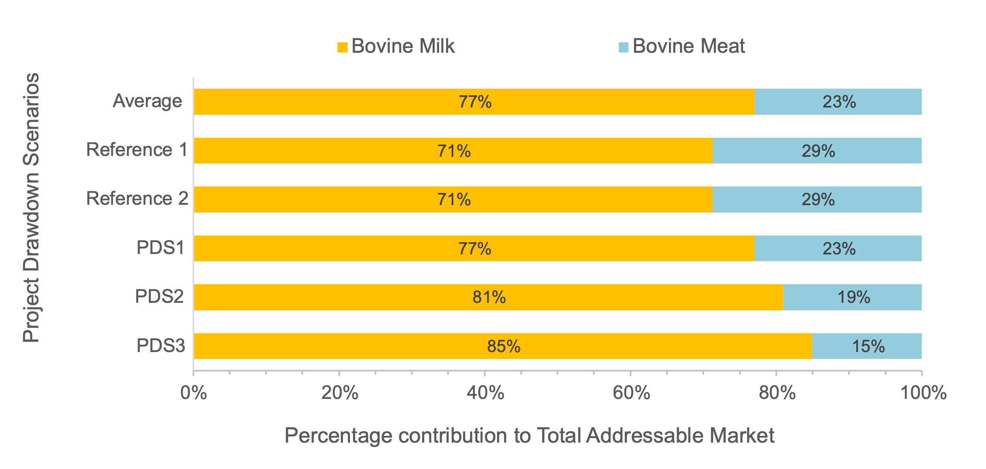

Figure . Fraction of TAM protein content coming from milk and bovine meat for the Project Drawdown Scenarios (PDS).

After taking the average of the five TAM projections shown above, we further disaggregate the global TAM by region and production system using the FAO GLEAM data. The majority (41%) of cattle production occurs in OECD90 countries. This is followed by Asia (22%), Latin America (17%), the Middle East & Africa (11%), and Eastern Europe (9%). Table 2.1 shows the distribution of cattle production systems by region for a grazing, mixed, and feedlot system. Overall, mixed systems predominate the production of milk and meat from cattle with 54-68% of the regional production. Grazing systems make a little over a third of production in most regions. Except for OECD90, feedlots generally produce less than 4% of cattle products.

Table . Distribution of Production Systems by Region

|  |  |  |  |  |
| --- | --- | --- | --- | --- |
|  |  | **Distribution of Production System in Corresponding Region** | | |
| **Region** | **Regional Fraction of Global TAM**  **(%)** | **Grazing System**  **(%)** | **Mixed-System**  **(%)** | **Feedlot**  **(%)** |
| OECD90 | 41 | 37 | 54 | 9 |
| Eastern Europe | 9 | 32 | 68 | 0 |
| Asia (Sans Japan) | 22 | 28 | 68 | 4 |
| Middle East and Africa | 11 | 44 | 56 | 1 |
| Latin America | 17 | 38 | 59 | 3 |

## Adoption Scenarios

Two different types of adoption scenarios were developed: A *Reference* (REF) Case which was considered the baseline, where not much changes in the world, and a set of *Project Drawdown Scenarios* (PDS) with varying levels of ambitious adoption of the solution. Published results show the comparison of one PDS to scenarios to the Reference, and therefore focus on the change to the world relative to a baseline. When developing our adoption scenarios, we consider two important criteria:

1. **Region**, the level of potential adoption will depend on what is feasible for a particular socioeconomic region. Those regions being:
   1. OECD90
   2. Eastern Europe
   3. Asia
   4. Middle East and Africa
   5. Latin America
2. **Cattle Production System,** conventional animal diets and farming practices vary based on the conditions the cattle are raised. Those systems include:
   1. Grazing – livestock animals spend most of their lives out on the pasture eating forages
   2. Mixed – farms are characterized as having both animal production and crop production. Animal diets contain forages and crop residues.
   3. Feedlots – confined in close-quartered spaces and yards, animal diets are optimized for fast weight and meat gain

### Reference Case / Current Adoption

The *Reference* (REF) Case scenario is characterized by a static current use of improved livestock feed over the next thirty years. This implies there is no new adoption of the solution. In 2014, the base year, the global production of cattle-sourced products was 43.9 billion kilograms of protein. Of the total production, around 21% or 9.1 billion kilograms of protein were produced using the improved livestock feed quality. By 2050, global demand for meat and milk production (i.e., the TAM) grows 31% to 57.6 billion kilograms of protein. Without any additional adoption of the solution, the REF scenario assumes improved feed diets remain at 21% of the total addressable market, or 11.9 billion kilograms of protein.

Current adoption assumed in the REF scenario varies by region and production system. As mentioned earlier, we disaggregate the world into regions and three primary production systems within each region as shown in Table 2.2 and in Figure 2.3. In general, feedlots represent the highest current adoption of the improved feed solution, up to 62% of the diet. This is because feedlots optimize cattle diets with high concentrates and grains to quickly fatten the meat cattle and improve milk quality. As for mixed-systems and grazing systems, adoption is generally lower (28-34%) for OECD90 and Eastern Europe, and significantly lower in developing regions (2-9%).

Table . Current Adoption by Region and Production System

|  |  |  |  |
| --- | --- | --- | --- |
| **Region** | **Grazing System**  **(%)** | **Mixed-System**  **(%)** | **Feedlot**  **(%)** |
| OECD90 | 30 | 34 | 55 |
| Eastern Europe | 28 | 32 | No feedlots in use |
| Asia (Sans Japan) | 5 | 8 | 22 |
| Middle East and Africa | 2 | 8 | 62 |
| Latin America | 3 | 9 | 36 |

Figure . Current Adoption of Improved Feed Quality and Nutrition by Region and Production System

### Custom Adoption Scenarios

For the three production systems in Project Drawdown each region, we define four levels of future adoption. The specific definitions of Limited, Ambitious, and Maximum in reference to region and production system are defined in Table 2.3.

1. *Stagnant* – no increase in adoption of the solution, use REF adoption estimate from Table 2.2
2. *Limited* – reasonable level of adoption within the confinements of current barriers
3. *Ambitious* – obtaining adoption above expected undertaking
4. *Maximum* – the greatest allowable level of adoption possible

Each level assumes a specific percent increase in adoption by 2050. Limited adoption supposes a +5 to +20% increase from current adoption, depending on the region and production system. Ambitious adoption goes a slightly further, by assuming adoption increases +15 to +45%. Finally, adoption cannot exceed 75%, because a farmer must maintain a balanced animal diet that contains at least 25% of conventional feed ingredients. Therefore, we set the Maximum adoption at 75% of the TAM.

As a note, we group regions together based on their similarities in farming practices and current adoption. Because current adoption between OECD90 and Eastern Europe are similar in percentage adoption, we group these two regions together and consider them as “Developed Regions”. We also group Asia, Middle East & Africa, and Latin America as “Developing Regions” since their current adoptions are all relatively smaller than the Developed Nations.

All projection scenarios use the *Average* projection of the Total Addressable Market, which assumes the demand for animal products continues to increase through 2050 but interventions of family planning & educating girls, plant-rich diets, and reduced food waste decrease some demand. We also assume a linear interpolation between current levels of adoption in 2014 and proposed levels of adoption in 2050.

Table . Definitions of Limited, Ambitious, and Maximum Adoption for Regional Groupings and Production Systems

|  |  |  |  |  |  |  |
| --- | --- | --- | --- | --- | --- | --- |
|  | **Grazing & Mixed System** | | | **Feedlots** | | |
| **Regional Groupings** | **Limited** | **Ambitious** | **Maximum** | **Limited** | **Ambitious** | **Maximum** |
| **“Developed Regions”**  OECD90,  Eastern Europe | +10% of current adoption | +30% of current adoption | Set at 75% adoption | +5% of current adoption | +15% of current adoption | Set at 75% adoption |
| **“Developing Regions”**  Asia, Middle East and Africa, Latin America | +20% of current adoption | +45% of current adoption | Set at 75% adoption | +10% of current adoption | +25% of current adoption | Set at 75% adoption |

From the four tiers of adoption that are specific to each region and production system (as defined in Table 2.3), we can construct several combinations of adoption potential for future projections:

* ***Custom Scenario 1:*** Adoption of the solution is **stagnant** in developing countries, but there is some **limited** adoption within developed countries
* ***Custom Scenario 2:*** Adoption is **limited** in developing countries, but adoption of the solution is **stagnant** in developed countries
* ***Custom Scenario 3:*** Adoption of the solution is applied but **limited** in both developing and developed countries
* ***Custom Scenario 4:*** Adoption of the solution is **limited** in developing countries, but **ambitious** adoption within developed countries
* ***Custom Scenario 5:* Ambitious** adoption in developing countries, but adoption of the solution is **limited** in developed countries
* ***Custom Scenario 6:* Ambitious** adoption of the solution in both developing and developed countries
* ***Custom Scenario 7:* Maximum** adoption of the solution in both developing and developed countries

Figure 2.4 World Adoption of Improved Feed Quality through 2050

### Project Drawdown Scenarios

Three *Project Drawdown scenarios* (PDS) were developed to compare the impact of an increased adoption of the solution to a *Reference* (REF)case scenario, being:

#### PDS 1 – A conservative approach is adopted, and future growth of the solution is estimated based on the average lower bound of all seven custom adoption scenarios (defined by the average minus the standard deviation of all scenarios).

#### PDS 2 – A progressive approach is adopted, and future growth of the solution is estimated based on the average of all seven custom adoption scenarios.

#### PDS 3 – An ambitious approach is adopted, and future growth of the solution is estimated based on the average upper bound of all seven custom adoption scenarios (defined by the average plus the standard deviation of all scenarios).

## Model Inputs

The Project Drawdown Reduction and Replacement Solutions (RRS) core model used to evaluate climate-positive technologies and practices such as improved livestock feed quality, requires climate and financial inputs collected from trustworthy sources.

### Direct and Indirect Emissions Inputs

To calculate the climate impacts of the Project Drawdown Scenarios, climate inputs of direct emissions from the conventional feeding system and improved feed quality solution are implemented into the model. Direct emissions include methane (CH4) emissions from enteric fermentation. Indirect emissions include carbon dioxide (CO2) emissions from the production, processing, and manufacturing of feed. All estimates of emissions aggregate all greenhouse gas emissions from a life-cycle analysis of milk and meat production into carbon dioxide equivalent emissions (CO2-eq). We assume a system boundary at the end of animal digestion.

A collection of 192 separate direct emissions estimates for the conventional feeding systems are gathered from peer-reviewed literature and FAO-based reports. Where possible, weights are assigned on a regional basis to account for the heterogeneity of animal production systems and the global distribution of animal populations. Literature emissions factors varied in implementation units, where common units include “kilograms of live weight” and “kg of fat and protein corrected milk”. All values are converted to “tonnes of CO2-eq emissions per kilogram of protein”.

In addition to conventional feeding emissions, Project Drawdown collects direct emissions related to the solution. For the improved livestock feed quality solution, 124 individual emissions estimates are collected. In the case where a percent reduction is defined in the literature but not an absolute value, we calculated the new value based on the reduction from the stated conventional emissions. Methane from enteric fermentation is assumed to be between 62-91% of total emissions, depending on the type of production system and country from which the study is based.

The feed quality solution *does not* model changes to the bio-sequestration of carbon, as the focus is on the changes to enteric methane emissions and not on changes to the land production.

Table . Climate Inputs

|  | **Units** | **Project Drawdown Data Set Range** | **Model Input** | **Data Points (#)** | **Sources (#)** |
| --- | --- | --- | --- | --- | --- |
| Direct Emissions from the Conventional Feeding System | t CO2-eq per kg of protein | 0.000 – 0.764 | 0.305 | 192 | 14 |
| Direct Emissions from the Improved Feed Quality Solution | t CO2-eq per kg of protein | 0.008 – 0.620 | 0.256 | 124 | 24 |
| Indirect Emissions from the Conventional Feeding System | t CO2-eq per kg of protein | 0.002 – 0.046 | 0.023 | 111 | 1[1] |
| Indirect Emissions from the Improved Feed Quality Solution | t CO2-eq per kg of protein | 0.000 – 0.026 | 0.011 | 84 | 13 |

Note: Project Drawdown data set range is defined by the low and high boundaries which are respectively one standard deviation below and above the mean of the collected data points[2].

### Financial Inputs

It is assumed there were no first costs to the conventional system and solution as conventional crop systems for feed production were already in place and no new or replacement machinery would be required. As the operating cost of the feeding systems, we considered the cost of producing and/or purchasing animal feed. Finding estimates of feed prices were difficult due to high variability as commodity prices were found to fluctuate under various market conditions. In addition, feed costs are usually influenced by the total feed intake of the animal which further varies by the animal’s health, age, and production phase.

Based on a meta-analysis of 19 data points from the International Farm Comparison Network, conventional operating costs are calculated as 30% soybean meal price and 70% corn prices for several representative dairy-producing countries. Published reports of cost-benefit analysis were used to estimate the cost of solutions in non-OECD countries. Costs of solutions in 2014 US dollars were estimated between US$ 0.14/kg protein and US$ 2.46/kg protein for beef production systems in Latin America (FAO and NZAGRC, 2017b and 2017c). For dairy production systems in South Asia and Africa, costs of solutions ranged from US$6.81/kg protein to US$ 85.61/kg protein (FAO and NZAGRC, 2017a and 2019). For our modelling work, we estimate the conventional cost of animal feed is $9.48 (2014 US dollars) per kilogram of protein from animal-sourced products. In comparison, operating costs for an alternative feed diet are estimated at $13.38 per kilogram of protein. This means overall, the cost of producing and buying feed off the market are more expensive for higher quality feedstuff.

Table . Financial Inputs for Conventional System and Solution

|  | **Units** | **Project Drawdown Data Set Range** | **Model Input** | **Data Points (#)** | **Sources (#)** |
| --- | --- | --- | --- | --- | --- |
| Operating cost for Conventional Feeding Systems | US$2014 per kg of protein | 6.80 – 12.16 | 9.48 | 19 | 1 |
| Operating cost for the Improved Feed Quality Solution | US$2014 per kg of protein | 0.99 – 25.78 | 13.38 | 98 | 4 |

### Other Inputs

An added benefit to an improved cattle diet is the increase in milk yield. Annual yield gains compared to business-as-usual were set at 13.3 kg protein per cow (416.9 kg milk/cow), based on meta-analysis of 18 data points from 7 sources. Over the 2020-2050 projection, a total of 12,507 kg of milk/cow is gained.

For a farmgate price of $24.48 per 100 kg milk (Olipra, 2019), the added milk yield equates to an additional $102.06 per cow each year. An average 50 cow farm would make an additional annual revenue of $5,103 in addition to the business-as-usual income. We model the additional savings as $8.53/kg protein. As noted in Section 2.5.2, the operating cost for the improved feed quality is more expensive than the conventional operating cost. However, with the additional revenue, the overall operating cost for the solution turns out to be less expensive. This makes the solution a cost-efficient alternative.

While improved feed for beef cattle would also lead to increases in weight gain and beef production from an improved diet, we do not model the additional revenue. This could be a future development in modelling.

Table 2.3 Yield Gains

|  | **Units** | **Project Drawdown Data Set Range** | **Model Input** | **Data Points (#)** | **Sources (#)** |
| --- | --- | --- | --- | --- | --- |
| Annual gain in milk yield | kg protein per cow | 0.78 – 25.90 | 13.34 | 18 | 4 |
| Additional revenue from increased milk yield | US$2014 per kg of protein | 1.40 – 15.67 | 8.53 | 13 | 4 |

## Assumptions

Six overarching assumptions have been made for Project Drawdown models to enable the development and integration of individual model solutions. These are that the infrastructure required for the solution is available and in-place, policies required are already in-place, no carbon price is modeled, all costs accrue at the level of agency modeled, improvements in technology are not modeled, and that first costs may change according to learning. Full details of core assumptions and methodology will be available at [www.drawdown.org](http://www.drawdown.org).

Beyond these core assumptions, there are other important assumptions made for the modeling of this specific solution. These are detailed below.

1. The selected livestock animal for this solution is cattle (both dairy and non-dairy).
2. All production systems (i.e. feedlot, mixed, grazing) will remain as the same type through 2050.
3. Machinery used for the conventional feeding system is the same and already established for the new feed solutions.
4. The land required for the production of feed and the extensive grazing of cattle will not increase or decrease.
5. Using the functional unit of kilograms protein allows for the number of animals to fluctuate along with their milk/meat production efficiency.

## Limitations/Further Development

In its current state, the Project Drawdown solution for improved livestock feed quality is limited in its application to only cattle. As cattle account for 70% of global enteric methane emissions the solution covers the vast majority of ruminant emissions. While the feed solution can be applicable to other large ruminants (buffalo) and small ruminants (like goats and sheep), much fewer data sources are available to indicate a change in diet will make a substantial reduction in enteric methane emissions.

Buffalos as large herbivores and small herbivores (sheep and goats) contribute 13% each to global enteric methane emissions (Figure 1.5). Feed additives such as 3-NOP are yet to receive certification for market distribution. Methane emissions in the livestock production cycle include enteric fermentation, manure treatment and storage, as well as field application of manure. Opportunities for further methane reductions may be found in buffalo and small herbivores production systems, feed additives that may become commercially available, and manure management in livestock production systems.

Finally, adoption by 2050 cannot reach 100%. We limit adoption of the improved feed quality to 75% because a farmer must maintain a balanced animal diet that contains at least 25% of conventional feed ingredients. Therefore, we set the maximum adoption at 75% of the TAM.

# Results

## Adoption

Below are shown the world adoptions of the solution in 2014 and 2050 of the analysis in functional units (kilograms of protein) and percent of total addressable market for the three Project Drawdown scenarios.

* Total adoption in the *PDS 1* Scenario is 16.1 billion kilograms of protein in 2050, representing 28.0% of the total cattle-derived products.
* Total adoption in the *PDS 2* Scenario is 26.0 billion kilograms of protein in 2050, representing 45.2% of the total cattle-derived products.
* Total adoption in the *PDS 3* Scenario is 35.9 billion kilograms of protein in 2050, representing 62.4% of the total cattle-derived products.

Table . World Adoption of the Solution

| **Solution** | **Units** | **Base Year (2014)** | **World Adoption by 2050** | | | |
| --- | --- | --- | --- | --- | --- | --- |
| **REF** | **PDS 1** | **PDS 2** | **PDS 3** |
| Improved Cattle Feed Quality | billion kilograms of protein | 9.13 | 11.9 | 16.1 | 26.0 | 35.9 |
| Adoption as a percent of total addressable market | 20.8% | 20.8% | 28.0% | 45.2% | 62.4% |

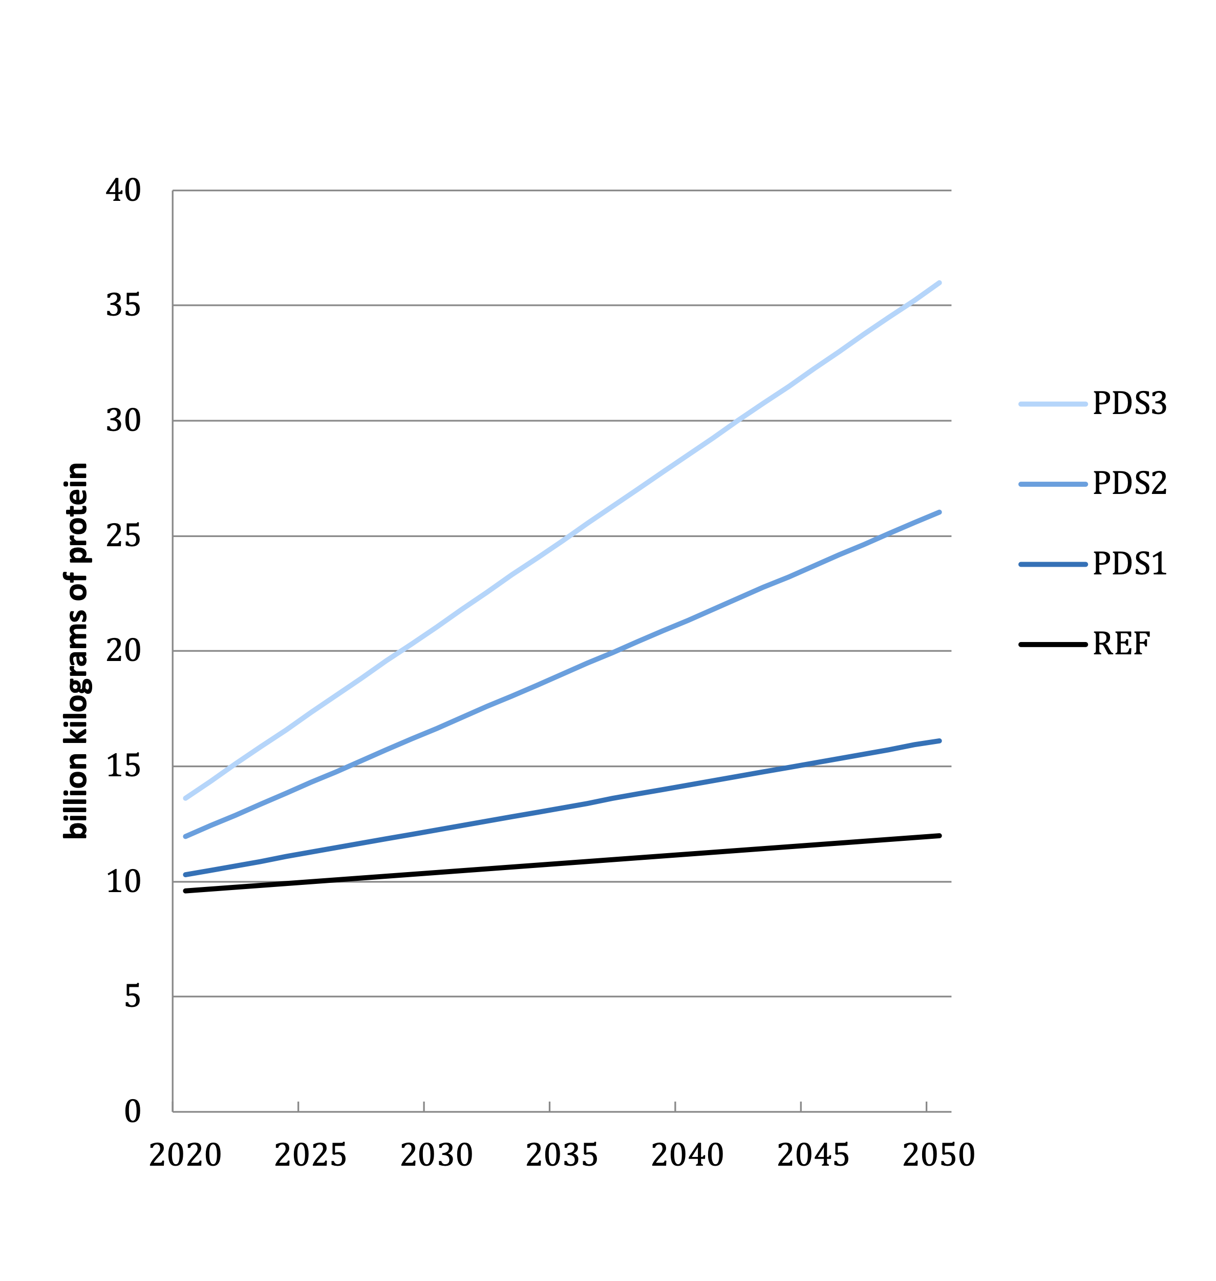

Figure . World Annual Adoption of Solution (2020-2050)

## Climate Impacts

Below are the emissions results of the analysis for each scenario which include total emissions reduction and atmospheric concentration changes. For a detailed explanation of each result, please see the glossary (Section 6).

Climate impact is 4.42, 15.05, and 26.68 gigatons of carbon-dioxide equivalent in the *PDS 1, PDS 2,* and *PDS 3* Scenarios respectively.

Table . Climate Impacts

| **Scenario** | **Maximum Annual Emissions Reduction** | **Total Emissions Reduction**  **(2020-2050)** | **Annual Emissions Reduction in 2030** | **Annual Emissions Reduction in 2050** |
| --- | --- | --- | --- | --- |
| *Gt CO2-eq/yr* | *Gt CO2-eq* | *Gt CO2-eq/yr* | *Gt CO2-eq/yr* |
| **PDS 1** | 0.24 | 4.42 | 0.11 | 0.24 |
| **PDS 2** | 0.83 | 15.05 | 0.37 | 0.83 |
| **PDS 3** | 1.42 | 26.68 | 0.63 | 1.42 |

The resulting impact on the atmospheric concentration change is 0.37, 1.25, and 2.13 parts per million in 2050 for *PDS 1*, *PDS 2*, and *PDS 3* Scenarios, respectively.

Table . Impacts on Atmospheric Concentrations of CO2-eq

| **Scenario** | **GHG Concentration Change in 2050** | **GHG Concentration Rate of Change in 2050** |
| --- | --- | --- |
| *PPM CO2-eq (2050)* | *PPM CO2-eq change (2049-2050)* |
| **PDS 1** | 0.37 | 0.02 |
| **PDS 2** | 1.25 | 0.06 |
| **PDS 3** | 2.13 | 0.11 |

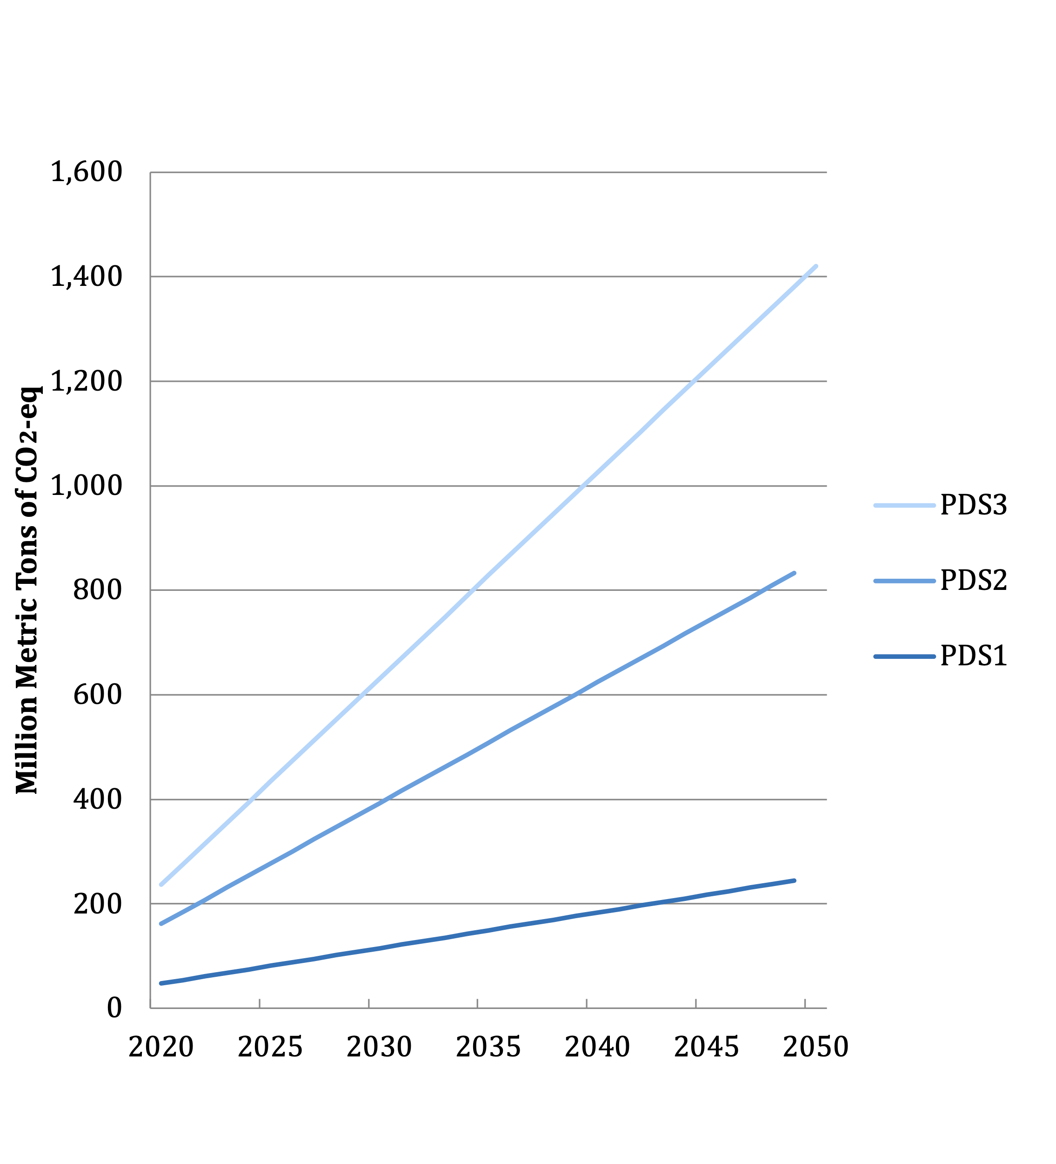

Figure . World AnnualGreenhouse Gas Emissions Reduction (2020-2050)

## Financial Impacts

Below are the financial results of the analysis for each scenario. For a detailed explanation of each result, please see the glossary. For all scenarios there isn’t a cumulative or marginal first cost because we assume all machinery is in place already from the conventional practice.

* For the *PDS 1* Scenario, net operating savings is US$0.34 trillion and Lifetime cashflow savings NPV is $0.55 trillion.
* For the *PDS 2* Scenario, net operating savings is US$1.17 trillion and Lifetime cashflow savings NPV is $1.88 trillion.
* For the *PDS 3* Scenario, net operating savings is US$1.99 trillion and Lifetime cashflow savings NPV is $3.22 trillion.

Table . Financial Impacts

| **Scenario** | **Cumulative First Cost** | **Marginal First Cost** | **Net Operating Savings** | **Lifetime Cashflow Savings NPV (of All Implementation Units)** |
| --- | --- | --- | --- | --- |
| *2015-2050 Trillion USD* | *2015-2050 Trillion USD* | *2020-2050 Trillion USD* | *2020- 2050*  *Trillion USD* |
| **PDS 1** | 0.00 | 0.00 | 0.34 | 0.55 |
| **PDS 2** | 0.00 | 0.00 | 1.17 | 1.88 |
| **PDS 3** | 0.00 | 0.00 | 1.99 | 3.22 |

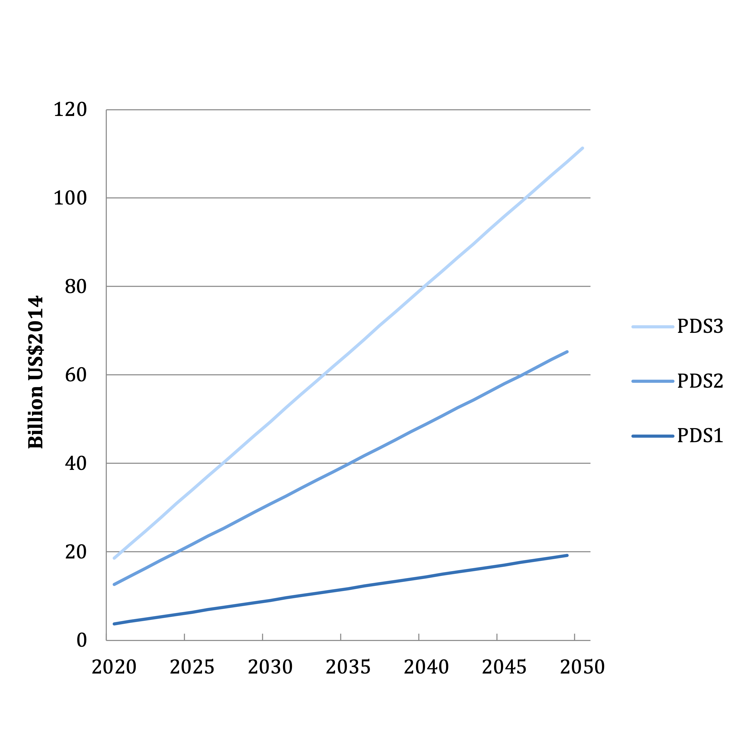

Figure . World Annual Operating Cost Reduction (2020-2050)

# Discussion

Project Drawdown modelled three potential adoption projections of *improved cattle feed quality* through 2050. Improved cattle feed quality is defined as a set of feeding strategies that lower enteric methane emissions by changing the composition and/or nutrient intake of the animal. This solution replaces conventional low-digestible rations such as high-fiber grasses and corn residue. The solution included feeding strategies of *high-quality forages*, *feed additives*, and *feed supplements.* Potential adoption of the strategies was based on what is currently implemented and what is technically feasible for different types of cattle production systems (grazing, mixed, and feedlot) in five socio-economic regions (OECD90, Eastern Europe, Asia, Middle East and Africa, and Latin America). Globally, adoption increased from 21% in the base year (2014) to a maximum of 62% in 2050. Plausible adoption is more likely to be 28% as seen in the first Project Drawdown Scenario (PDS 1).

Results indicate that total emissions reductions can be 4.4 – 26.6 Gt CO2-eq for a thirty-year timespan between 2020 and 2050. The maximum annual emissions reductions of 0.24 – 1.42 Gt CO2-eq/yr are reached in 2050. The implementation of improved cattle feed quality could significantly reduce the amount of CO2-equivalent greenhouse gas concentrations in the atmosphere by 0.37 – 2.13 parts per million (ppm) in 2050. It is important to note that while we express everything in CO2-equivalent units, the majority (~98%) of the emissions reductions are coming from methane. Having a short lifetime of approximately a decade, a significant reduction in methane will have the greatest effect on global warming in the near-term. In light of this, the use of the 100-year Global Warming Potential (GWP) may be misrepresenting the potential impact of reducing methane on a thirty-year timescale. Using the 20-year GWP for methane will more accurately measure the heat absorbed by methane over the modelled time period. It will also triple the values of our stated emissions reductions (an increase in GWP conversion factor from 28 to 84).

In addition to the climate impacts, Project Drawdown also modelled the financial implications of adopting improved cattle feed quality on the global scale. Although the cost of using a higher quality feed is higher than conventional feed, the added revenue from increased milk production outweighs the extra burden of an upfront cost. An additional benefit to this is less animals are needed to meet the demand for milk. And with fewer animals, the pressure on required natural resources is lightened. On the global scale, the added revenue will save US$ 0.55 – 3.22 trillion over the thirty-year projection. To put that into perspective, the 2019 global cattle feed market was US$ 74.8 billion and is expected to grow, compound annually, at a rate of 3.2% for at least the next seven years (Grand View Research, Inc., 2020).

## Benchmarks

Project Drawdown estimates *improved cattle feed quality* reduces 0.11 – 0.63 Gt CO2-eq emissions in 2030 and 0.24 – 1.42 Gt CO2-eq emissions in 2050. Table 4.1 lists available external sources and their mitigation impacts. Benchmarks vary widely depending on assumptions made about what feed ingredients are used and if they are used in combination with other livestock mitigation solutions like animal management and manure management. Overall, 11 sources estimate that 0.1 – 0.3 Gt CO2-eq can be reduced in 2030 and 0.01 – 1.72 Gt CO2-eq reduced in 2050. The Drawdown model’s calculations are thus in line with the benchmarks.

Table . Benchmarks

| **External Source** | **Scenario Description** | **Mitigation Impact (2030)**  *Gt CO2-eq/yr* | **Mitigation Impact (2050)**  *Gt CO2-eq/yr*  Low | High | |
| --- | --- | --- | --- | --- |
| EPA (2019) | livestock sector mitigation | 0.30 | 0.32 | |
| EPA (2019) | improved feed conversion | 0.03 | --- | |
| EPA (2013) | livestock sector mitigation | 0.27 | --- | |
| EPA (2013) | improved feed conversion | 0.03 | --- | |
| Beach et al. (2015) | livestock sector mitigation | 0.27 | --- | --- |
| Herrero et al. (2016) | use of feed additives | --- | 0.22 | 0.30 |
| Herrero et al. (2016) | improved feed digestibility | --- | 0.12 | 0.68 |
| Herrero et al. (2016) | animal productivity and health | --- | --- | 0.20 |
| Roe et al. (2019) | better feed and animal management | --- | 0.10 | 1.20 |
| Griscom et al. (2017) | legumes on pastures | --- | 0.01 | 1.50 |
| Griscom et al. (2017) | improved cattle feed | --- | 0.03 | 1.00 |
| Griscom et al. (2017) | animal management |  | 0.07 | 0.21 |
| Harmen et al. (2019) | improved cattle feed and animal management | --- | --- | 1.20 |
| Hoglund-Isaksson et al. (2020) | improved cattle feed and animal management (dairy + non-dairy cows) | --- | --- | 0.38 |
| Frank et al. (2018) | improved feed digestibility | 0.1 | --- | 0.09 |
| Caro et al. (2016) | supplementation of lipids | 0.1 |  |  |
| Gerber et al. (2013) | cattle mitigation that narrows the emission intensity “gap” between highest emitting nations and lowest emitting nations | --- | --- | 1.72 |

# References

Abecia, L., Toral, P. G., Martín-García, A. I., Martínez, G., Tomkins, N. W., Molina-Alcaide, E., ... & Yáñez-Ruiz, D. R. (2012). Effect of bromochloromethane on methane emission, rumen fermentation pattern, milk yield, and fatty acid profile in lactating dairy goats. *Journal of dairy science*, *95*(4), 2027-2036.

Aguirre-Villegas, H., Larson, R. A., Ruark, M. D., Liang, D., Wattiaux, M., Chase, L., & Cabrera, V. (2017). Mitigation of Enteric Methane Emissions from Dairy Cows. Sustainable Dairy Fact Sheet Series.

Aguirre-Villegas, H. A., Passos-Fonseca, T. H., Reinemann, D. J., Armentano, L. E., Wattiaux, M. A., Cabrera, V. E., ... & Larson, R. (2015). Green cheese: Partial life cycle assessment of greenhouse gas emissions and energy intensity of integrated dairy production and bioenergy systems. Journal of dairy science, 98(3), 1571-1592.

Ahmed, E., Yano, R., Fujimori, M., Kand, D., Hanada, M., Nishida, T., & Fukuma, N. (2020). Impacts of Mootral on methane production, rumen fermentation, and microbial community in an in vitro study. *Frontiers in veterinary science*, *7*.

Archimède, H., Eugène, M., Magdeleine, C. M., Boval, M., Martin, C., Morgavi, D. P., ... & Doreau, M. (2011). Comparison of methane production between C3 and C4 grasses and legumes. *Animal Feed Science and Technology*, *166*, 59-64.

Appuhamy, J. R. N., Strathe, A. B., Jayasundara, S., Wagner-Riddle, C., Dijkstra, J., France, J., & Kebreab, E. (2013). Anti-methanogenic effects of monensin in dairy and beef cattle: A meta-analysis. *Journal of Dairy Science*, *96*(8), 5161-5173.

Beauchemin, K. A., Kreuzer, M., O’mara, F., & McAllister, T. A. (2008). Nutritional management for enteric methane abatement: a review. *Australian Journal of Experimental Agriculture*, *48*(2), 21-27.

Chung, Y. H., Zhou, M., Holtshausen, L., Alexander, T. W., McAllister, T. A., Guan, L. L., ... & Beauchemin, K. A. (2012). A fibrolytic enzyme additive for lactating Holstein cow diets: ruminal fermentation, rumen microbial populations, and enteric methane emissions. *Journal of dairy science*, *95*(3), 1419-1427.

Banik, B. K., Durmic, Z., Erskine, W., Ghamkhar, K., & Revell, C. (2013). In vitro ruminal fermentation characteristics and methane production differ in selected key pasture species in Australia. *Crop and Pasture Science*, *64*(9), 935-942.

Bar-On, Y. M., Phillips, R., & Milo, R. (2018). The biomass distribution on Earth. Proceedings of the National Academy of Sciences, 115(25), 6506-6511.

Beach, R. H., Creason, J., Ohrel, S. B., Ragnauth, S., Ogle, S., Li, C., ... & Salas, W. (2015). Global mitigation potential and costs of reducing agricultural non-CO2 greenhouse gas emissions through 2030. Journal of Integrative Environmental Sciences, 12(sup1), 87-105.

Belanche, A., Newbold, C.J., Morgavi, D.P., Bach, A., Zweifel, B., & Yáñez-Ruiz, D.R. (2020). A Meta-analysis Describing the Effects of the Essential oils Blend Agolin Ruminant on Performance, Rumen Fermentation and Methane Emissions in Dairy Cows. Animals 2020, 10 (4), 620

Bhatta, R., & Enishi, O. (2007). Measurement of methane production from ruminants. Asian-australasian journal of animal sciences, 20(8), 1305-1318.

Birhan, M., & Adugna, T. (2014). Livestock feed resources assessment, constraints and improvement strategies in Ethiopia. Middle East Journal of Scientific Research, 21(4), 616.

Broucek, J. (2014). Production of methane emissions from ruminant husbandry: a review. Journal of Environmental Protection, 5(15), 1482.

Byrne, J. 2020. DSM flag huger reduction of methane emissions in Canadian beef cattle rial using feed additive. Accessed 01 March, 2021. <https://www.feednavigator.com/Article/2020/12/17/DSM-flags-huge-reduction-of-methane-emissions-in-Canadian-beef-cattle-trial-using-feed-additive>

Caro, D., Kebreab, E., & Mitloehner, F. M. (2016). Mitigation of enteric methane emissions from global livestock systems through nutrition strategies. Climatic Change, 137(3), 467-480.

Collins, W. J., Webber, C. P., Cox, P. M., Huntingford, C., Lowe, J., Sitch, S., ... & Powell, T. (2018). Increased importance of methane reduction for a 1.5 degree target. Environmental Research Letters, 13(5), 054003.

Dijkstra, J., Bannink, A., France, J., Kebreab, E., & Van Gastelen, S. (2018). Antimethanogenic effects of 3-nitrooxypropanol depend on supplementation dose, dietary fiber content, and cattle type. *Journal of dairy science*, *101*(10), 9041-9047.

Duin, E. C., Wagner, T., Shima, S., Prakash, D., Cronin, B., Yáñez-Ruiz, D. R., ... & Kindermann, M. (2016). Mode of action uncovered for the specific reduction of methane emissions from ruminants by the small molecule 3-nitrooxypropanol. *Proceedings of the National Academy of Sciences*, *113*(22), 6172-6177.

Duffield, T. F., Rabiee, A. R., & Lean, I. J. (2008). A meta-analysis of the impact of monensin in lactating dairy cattle. Part 1. Metabolic effects. Journal of dairy science, 91(4), 1334-1346.

EPA. (2013). Global mitigation of non‐CO2 greenhouse gases: 2010‐2030. United States Environmental Protection Agency Washington (DC).

EPA. (2019). Global Non-CO2 Greenhouse Gas Emission Projections and Mitigation: 2015-2050. United States Environmental Protection Agency Washington (DC).

Eger, M., Graz, M., Riede, S., & Breves, G. (2018). Application of MootralTM reduces methane production by altering the archaea community in the rumen simulation technique. *Frontiers in microbiology*, *9*, 2094.

FAO. (2019). Five practical actions towards low-carbon livestock. Food and Agriculture Organization of the United Nations (FAO). Rome.

FAO & New Zealand Agricultural Greenhouse Gas Research Centre (NZAGRC). (2019). Options for low emission development in the Tanzania dairy sector - reducing enteric methane for food security and livelihoods. Rome.

FAO & New Zealand Agricultural Greenhouse Gas Research Centre (NZAGRC). (2017a). Options for low emission development in the Bangladesh dairy sector – reducing enteric methane for food security and livelihoods. Rome.

FAO & New Zealand Agricultural Greenhouse Gas Research Centre (NZAGRC). (2017b). Low-emissions development of the beef cattle sector in Argentina - Reducing enteric methane for food security and livelihoods. Rome.

FAO & New Zealand Agricultural Greenhouse Gas Research Centre (NZAGRC). (2017c). Low emissions development of the beef cattle sector in Uruguay – reducing enteric methane for food security and livelihoods. Rome.

FAOSTAT. (2021). FAOSTAT Database. Food and Agriculture Organization of the United Nations (FAO). Rome. Retrieved February 10, 2021 from <http://www.fao.org/faostat/>

Firkins, J. L., Eastridge, M. L., St-Pierre, N. R., & Noftsger, S. M. (2001). Effects of grain variability and processing on starch utilization by lactating dairy cattle. Journal of Animal Science, 79(suppl_E), E218-E238.

Frank, S., Beach, R., Havlík, P., Valin, H., Herrero, M., Mosnier, A., ... & Obersteiner, M. (2018). Structural change as a key component for agricultural non-CO 2 mitigation efforts. Nature communications, 9(1), 1-8.

Gerber, P. J., Steinfeld, H., Henderson, B., Mottet, A., Opio, C., Dijkman, J., ... & Tempio, G. (2013). Tackling climate change through livestock: a global assessment of emissions and mitigation opportunities. Food and Agriculture Organization of the United Nations (FAO).

Goel, G., & Makkar, H. P. (2012). Methane mitigation from ruminants using tannins and saponins. *Tropical animal health and production*, *44*(4), 729-739.

Grainger, C., Clarke, T., Auldist, M. J., Beauchemin, K. A., McGinn, S. M., Waghorn, G. C., & Eckard, R. J. (2009). Potential use of Acacia mearnsii condensed tannins to reduce methane emissions and nitrogen excretion from grazing dairy cows. Canadian Journal of Animal Science, 89(2), 241-251.

Grand View Research Inc. (2020). Cattle Feed Market Size, Share & Trends Analysis Report By Ingredients (Wheat, Corn, Additives), By Application (Dairy Beef), By Region (North America, Asia Pacific), and Segment Forecasts, 2020-2027.

Griscom, B. W., Adams, J., Ellis, P. W., Houghton, R. A., Lomax, G., Miteva, D. A., ... & Fargione, J. (2017). Natural climate solutions. Proceedings of the National Academy of Sciences, 114(44), 11645-11650.

Gro-Intelligence. (2017). Livestock 2050: Feed gets smarter. Retrieved February 23, 2021, from <https://gro-intelligence.com/insights/articles/livestock-demand-smarter-feed-2050>

Haisan, J., Sun, Y., Guan, L. L., Beauchemin, K. A., Iwaasa, A., Duval, S., ... & Oba, M. (2014). The effects of feeding 3-nitrooxypropanol on methane emissions and productivity of Holstein cows in mid lactation. Journal of dairy science, 97(5), 3110-3119.

Harmsen, J. H. M., van Vuuren, D. P., Nayak, D. R., Hof, A. F., Höglund-Isaksson, L., Lucas, P. L., ... & Stehfest, E. (2019). Long-term marginal abatement cost curves of non-CO2 greenhouse gases. Environmental Science & Policy, 99, 136-149.

Hassanat, F., & Benchaar, C. (2013). Assessment of the effect of condensed (acacia and quebracho) and hydrolysable (chestnut and valonea) tannins on rumen fermentation and methane production in vitro. *Journal of the Science of Food and Agriculture*, *93*(2), 332-339.

Hegarty, R. S., & Gerdes, R. (1999). Hydrogen production and transfer in the rumen. Recent Advances in Animal Nutrition in Australia, 12, 37-44.

Herrero, M., Henderson, B., Havlík, P., Thornton, P. K., Conant, R. T., Smith, P., ... & Stehfest, E. (2016). Greenhouse gas mitigation potentials in the livestock sector. Nature Climate Change, 6(5), 452-461.

Höglund-Isaksson, L., Gómez-Sanabria, A., Klimont, Z., Rafaj, P., & Schöpp, W. (2020). Technical potentials and costs for reducing global anthropogenic methane emissions in the 2050 timeframe–results from the GAINS model. Environmental Research Communications, 2(2), 025004.

Hook, S. E., Steele, M. A., Northwood, K. S., Wright, A. D. G., & McBride, B. W. (2011). Impact of high-concentrate feeding and low ruminal pH on methanogens and protozoa in the rumen of dairy cows. Microbial ecology, 62(1), 94-105.

Hristov, A. N., Oh, J., Firkins, J. L., Dijkstra, J., Kebreab, E., Waghorn, G., ... & Tricarico, J. M. (2013). Special topics—Mitigation of methane and nitrous oxide emissions from animal operations: I. A review of enteric methane mitigation options. *Journal of animal science*, *91*(11), 5045-5069.

Hristov, A. N., Oh, J., Giallongo, F., Frederick, T. W., Harper, M. T., Weeks, H. L., ... & Duval, S. (2015). An inhibitor persistently decreased enteric methane emission from dairy cows with no negative effect on milk production. *Proceedings of the national academy of sciences*, *112*(34), 10663-10668.

Hook, S. E., Steele, M. A., Northwood, K. S., Wright, A. D. G., & McBride, B. W. (2011). Impact of high-concentrate feeding and low ruminal pH on methanogens and protozoa in the rumen of dairy cows. Microbial ecology, 62(1), 94-105.

Hulshof, R. B. A., Berndt, A., Gerrits, W. J. J., Dijkstra, J., Van Zijderveld, S. M., Newbold, J. R., & Perdok, H. B. (2012). Dietary nitrate supplementation reduces methane emission in beef cattle fed sugarcane-based diets. *Journal of animal science*, *90*(7), 2317-2323.

Immig, I. (1996). The rumen and hindgut as source of ruminant methanogenesis. *Environmental monitoring and assessment*, *42*(1), 57-72.

IPCC. (2019). Refinement to the 2006 IPCC Guidelines for National Greenhouse Gas Inventories, Calvo Buendia, E., Tanabe, K., Kranjc, A., Baasansuren, J., Fukuda, M., Ngarize, S., Osako, A., Pyrozhenko, Y., Shermanau, P. and Federici, S. (Eds.).

Jayanegara, A., Leiber, F., & Kreuzer, M. (2012). Meta‐analysis of the relationship between dietary tannin level and methane formation in ruminants from in vivo and in vitro experiments. *Journal of animal physiology and animal nutrition*, *96*(3), 365-375.

Johnson, K. A., Kincaid, R. L., Westberg, H. H., Gaskins, C. T., Lamb, B. K., & Cronrath, J. D. (2002). The effect of oilseeds in diets of lactating cows on milk production and methane emissions. Journal of dairy science, 85(6), 1509-1515.

Knapp, J. R., Laur, G. L., Vadas, P. A., Weiss, W. P., & Tricarico, J. M. (2014). Invited review: Enteric methane in dairy cattle production: Quantifying the opportunities and impact of reducing emissions. *Journal of dairy science*, *97*(6), 3231-3261.

Knight, T., Ronimus, R. S., Dey, D., Tootill, C., Naylor, G., Evans, P., ... & Clark, H. (2011). Chloroform decreases rumen methanogenesis and methanogen populations without altering rumen function in cattle. *Animal Feed Science and Technology*, *166*, 101-112.

Lawrence, J. D., Mintert, J. R., Anderson, J. D., & Anderson, D. P. (2008). Feed grains and livestock: Impacts on meat supplies and prices. Choices, 23(316-2016-6897), 11-15.

Lila, Z. A., Mohammed, N., Yasui, T., Kurokawa, Y., Kanda, S., & Itabashi, H. (2004). Effects of a twin strain of Saccharomyces cerevisiae live cells on mixed ruminal microorganism fermentation in vitro. *Journal of animal science*, *82*(6), 1847-1854.

Lee, C., & Beauchemin, K. A. (2014). A review of feeding supplementary nitrate to ruminant animals: nitrate toxicity, methane emissions, and production performance. *Canadian Journal of Animal Science*, *94*(4), 557-570.

Le Liboux, S., & Peyraud, J. L. (1999). Effect of forage particle size and feeding frequency on fermentation patterns and sites and extent of digestion in dairy cows fed mixed diets. Animal feed science and technology, 76(3-4), 297-319.

Lowder, S. K., Skoet, J., & Raney, T. (2016). The number, size, and distribution of farms, smallholder farms, and family farms worldwide. World Development, 87, 16-29.

MacLeod, M., Eory, V., Gruère, G., & Lankoski, J. (2015). Cost-effectiveness of greenhouse gas mitigation measures for agriculture. Organisation for Economic Co-operation and Development (OECD): Paris, France.

MacLeod, M., Gerber, P., Mottet, A., Tempio, G., Falcucci, A., Opio, C., ... & Steinfeld, H. (2013). Greenhouse gas emissions from pig and chicken supply chains–A global life cycle assessment. Food and Agriculture Organization of the United Nations.

Mahesh, M. S., Mohanta, R. K., & Patra, A. K. (2021). Probiotics in livestock and poultry nutrition and health. In *Advances in Probiotics for Sustainable Food and Medicine*(pp. 149-179). Springer, Singapore.

Martinez-Fernandez, G., Arco, A., Abecia, L., Cantalapiedra-Hijar, G., Molina-Alcaide, E., Martin-Garcia, A. I., ... & Yanez-Ruiz, D. R. (2013). The addition of ethyl-3-nitrooxy propionate and 3-nitrooxypropanol in the diet of sheep substantially reduces methane emissions and the effect persists over a month. *Adv. Anim. Biosci*, *4*(2), 368.

Matthews, C., Crispie, F., Lewis, E., Reid, M., O’Toole, P. W., & Cotter, P. D. (2019). The rumen microbiome: a crucial consideration when optimising milk and meat production and nitrogen utilisation efficiency. Gut microbes, 10(2), 115-132.

McSweeney, C., & Mackie, R. (2012). Commission on genetic resources for food and agriculture. Micro-organisms and ruminant digestion: State of knowledge, trends and future prospects. Background Study Paper (FAO), 61, 1-62.

Melgar, A., Lage, C. F. A., Nedelkov, K., Räisänen, S. E., Stefenoni, H., Fetter, M. E., ... & Hristov, A. N. (2021). Enteric methane emission, milk production, and composition of dairy cows fed 3-nitrooxypropanol. *Journal of dairy science*, *104*(1), 357-366.

Mitsumori, M., Shinkai, T., Takenaka, A., Enishi, O., Higuchi, K., Kobayashi, Y., ... & McSweeney, C. S. (2012). Responses in digestion, rumen fermentation and microbial populations to inhibition of methane formation by a halogenated methane analogue. *British Journal of Nutrition*, *108*(3), 482-491.

Moss, A. R., Jouany, J. P., & Newbold, J. (2000). Methane production by ruminants: its contribution to global warming. In Annales de zootechnie (Vol. 49, No. 3, pp. 231-253). EDP Sciences.

Mottet, A., de Haan, C., Falcucci, A., Tempio, G., Opio, C., & Gerber, P. (2017). Livestock: on our plates or eating at our table? A new analysis of the feed/food debate. *Global Food Security*, *14*, 1-8.

Muñoz, C., Yan, T., Wills, D. A., Murray, S., & Gordon, A. W. (2012). Comparison of the sulfur hexafluoride tracer and respiration chamber techniques for estimating methane emissions and correction for rectum methane output from dairy cows. *Journal of dairy science*, *95*(6), 3139-3148.

Myhre, G., Shindell, D., Bréon, F., Collins, W., Fuglestvedt, J., Huang, J., Koch, D., Lamarque, J., Lee, D., Mendoza, B., Nakajima, T., Robock, A., Stephens, G., Takemura, T., Zhang, H., Qin, D., Plattner, G., Tignor, M., Allen, S., … & Midgley, P. (2013). Anthropogenic and natural radiative forcing. In: Climate change 2013: the physical science basis. Contribution of working group I. In Climate Change 2013 - The Physical Science Basis.

Newbold, C. J., López, S., Nelson, N., Ouda, J. O., Wallace, R. J., & Moss, A. R. (2005). Propionate precursors and other metabolic intermediates as possible alternative electron acceptors to methanogenesis in ruminal fermentation in vitro. *British Journal of nutrition*, *94*(1), 27-35.

Olijhoek, D. W., Hellwing, A. L. F., Brask, M., Weisbjerg, M. R., Højberg, O., Larsen, M. K., ... & Lund, P. (2016). Effect of dietary nitrate level on enteric methane production, hydrogen emission, rumen fermentation, and nutrient digestibility in dairy cows. *Journal of dairy science*, *99*(8), 6191-6205.

Olipra, J. (2019). Cycles in the global milk market. *Journal of Agribusiness and Rural Development*, *52*(2), 165-172.

Opio, C., Gerber, P., Mottet, A., Falcucci, A., Tempio, G., MacLeod, M., ... & Steinfeld, H. (2013). Greenhouse gas emissions from ruminant supply chains–A global life cycle assessment. Food and agriculture organization of the United Nations.

Patra, A. K. (2010). Meta‐analyses of effects of phytochemicals on digestibility and rumen fermentation characteristics associated with methanogenesis. *Journal of the Science of Food and Agriculture*, *90*(15), 2700-2708.

Pelletier, N., & Tyedmers, P. (2010). Forecasting potential global environmental costs of livestock production 2000–2050. Proceedings of the National Academy of Sciences, 107(43), 18371-18374.

Roe, S., Streck, C., Obersteiner, M., Frank, S., Griscom, B., Drouet, L., ... & Lawrence, D. (2019). Contribution of the land sector to a 1.5 C world. Nature Climate Change, 9(11), 817-828.

Roque, B. M., Salwen, J. K., Kinley, R., & Kebreab, E. (2019). Inclusion of Asparagopsis armata in lactating dairy cows’ diet reduces enteric methane emission by over 50 percent. Journal of Cleaner Production, 234, 132-138.

Revell, B. J. (2015). One Man's Meat… 2050? Ruminations on future meat demand in the context of global warming. *Journal of agricultural economics*, *66*(3), 573-614.

Reynolds, C. K., Humphries, D. J., Kirton, P., Kindermann, M., Duval, S., & Steinberg, W. (2014). Effects of 3-nitrooxypropanol on methane emission, digestion, and energy and nitrogen balance of lactating dairy cows. *Journal of dairy science*, *97*(6), 3777-3789.

Romero-Perez, A., Okine, E. K., McGinn, S. M., Guan, L. L., Oba, M., Duval, S. M., ... & Beauchemin, K. A. (2015). Sustained reduction in methane production from long-term addition of 3-nitrooxypropanol to a beef cattle diet. *Journal of Animal Science*, *93*(4), 1780-1791.

Satyanagalakshmi, K., Sridhar, G. T., & Sirohi, S. K. (2015). An overview of the role of rumen methanogens in methane emission and its reduction strategies. African Journal of Biotechnology, 14(16), 1427-1438.

Thornton, P. K. (2010). Livestock production: recent trends, future prospects. Philosophical Transactions of the Royal Society B: Biological Sciences, 365(1554), 2853-2867.

Thornton, P. K., & Herrero, M. (2010). Potential for reduced methane and carbon dioxide emissions from livestock and pasture management in the tropics. Proceedings of the National Academy of Sciences, 107(46), 19667-19672.

Torrent, J., & Johnson, D. E. (1994). Methane production in the large intestine of sheep. Publication-European Association for Animal Production, 76, 391-391.

van Gastelen, S., Dijkstra, J., Binnendijk, G., Duval, S. M., Heck, J. M., Kindermann, M., ... & Bannink, A. (2020). 3-Nitrooxypropanol decreases methane emissions and increases hydrogen emissions of early lactation dairy cows, with associated changes in nutrient digestibility and energy metabolism. *Journal of Dairy Science*, *103*(9), 8074-8093.

Van Wesemael, D. (2019). *Enteric methane mitigation in dairy cattle via feeding strategies and the impact on the carbon footprint* (Doctoral dissertation, Ghent University).

Vrancken, H., Suenkel, M., Hargreaves, P. R., Chew, L., & Towers, E. (2019). Reduction of Enteric Methane Emission in a Commercial Dairy Farm by a Novel Feed Supplement. *Open Journal of Animal Sciences*, *9*(3), 286-296.

Vyas, D., McGeough, E. J., Mohammed, R., McGinn, S. M., McAllister, T. A., & Beauchemin, K. A. (2014). Effects of Propionibacterium strains on ruminal fermentation, nutrient digestibility and methane emissions in beef cattle fed a corn grain finishing diet. *Animal*, *8*(11), 1807-1815.

Waghorn, G. C., Clark, H., Taufa, V., & Cavanagh, A. (2008). Monensin controlled-release capsules for methane mitigation in pasture-fed dairy cows. *Australian Journal of Experimental Agriculture*, *48*(2), 65-68.

Yang, W. Z., Oba, M., & McAllister, T. A. (2012). Precision processing maximizes the feed value of barley grain for feedlot cattle. *Prairie Post Bull Breeders. p. A12–13*.

Zwick, S. (2017). Can this swiss feed supplement do for cows what Tesla is doing for cars? Ecosystem Marketplace. Retrieved March 1, 2021 from https://www.ecosystemmarketplace.com/articles/can-mootral-do-for-cows-what-tesla-is-doing-for-cars/

# Glossary

**Adoption Scenario** – the predicted annual adoption over the period 2015 to 2060, which is usually measured in **Functional Units**. A range of scenarios is programmed in the model, but the user may enter her own. Note that the assumption behind most scenarios is one of growth. If for instance a solution is one of reduced heating energy usage due to better insulation, then the solution adoption is translated into an increase in use of insulation. There are two types of adoption scenarios in use: **Reference (REF)** where global adoption remains mostly constant, and **Project Drawdown Scenarios (PDS)** which illustrate high growth of the solution.

**Approximate PPM Equivalent** – the reduction in atmospheric concentration of CO2 (in **PPM**) that is expected to result if the **PDS Scenario** occurs. This assumes a discrete avoided pulse model based on the Bern Carbon Cycle model.

**Average Abatement Cost** – the ratio of the present value of the solution (**Net** **Operating Savings** minus **Marginal First Costs**) and the **Total Emissions Reduction**. This is a single value for each solution for each **PDS Scenario**, and is used to build the characteristic “*Marginal Abatement Cost*” curves when Average Abatement Cost values for each solution are ordered and graphed.

**Average Annual Use** – the average number of functional units that a single implementation unit typically provides in one year. This is usually a weighted average for all users according to the data available. For instance, total number of passenger-km driven by a hybrid vehicle in a year depends on country and typical number of occupants. We take global weighted averages for this input. This is used to estimate the **Replacement Time**.

**Cumulative First Cost** – the total **First Cost** of solution **Implementation Units** purchased in the **PDS Scenario** in the analysis period. The number of solution implementation units that are available to provide emissions reduction during the analysis period is dependent on the units installed prior to the analysis period, and hence all implementation units installed after the base year are included in the cumulative first costing (that is 2015-2050).

**Direct Emissions** – emissions caused by the operation of the solution, which are typically caused over the lifetime of the solution. They should be entered into the model normalized per functional unit.

**Discount Rate**- the interest rate used in discounted cash flow (DCF) analysis to determine the present value of future cash flows. The discount rate in DCF analysis takes into account not just the time value of money, but also the risk or uncertainty of future cash flows; the greater the uncertainty of future cash flows, the higher the discount rate. Most importantly, the greater the discount rate, the more the future savings are devalued (which impacts the financial but not the climate impacts of the solution).

**Emissions** **Factor**– the average normalized emissions resulting from consumption of a unit of electricity across the global grid. Typical units are kg CO2e/kWh.

**First Cost**- the investment cost per **Implementation Unit** which is essentially the full cost of establishing or implementing the solution. This value, measured in 2014$US, is only accurate to the extent that the cost-based analysis is accurate. The financial model assumes that the first cost is made entirely in the first year of establishment and none thereafter (that is, no amortization is included). Thus, both the first cost and operating cost are factored in the financial model for the first year of implementation, all years thereafter simply reflect the operating cost until replacement of the solution at its end of life.

**Functional Unit** – a measurement unit that represents the value, provided to the world, of the function that the solution performs. This depends on the solution. Therefore, LED Lighting provides petalumen-hours of light, Biomass provides tera-watt-hours of electricity and high speed rail provides billions of passenger-km of mobility.

**Grid Emissions** – emissions caused by use of the electricity grid in supplying power to any operation associated with a solution. They should be in the units described below each variable entry cell. Drawdown models assume that the global electric grid, even in a Reference Scenario, is slowly getting cleaner, and that emissions factors fall over time resulting in lower grid emissions for the same electricity demand.

**Implementation Unit** – a measurement unit that represents how the solution practice or technology will be installed/setup and priced. The implementation unit depends on the solution. For instance, implementing electric vehicles (EV) is measured according to the number of actual EV’s in use, and adoption of Onshore Wind power is measured according to the total terawatts (TW) of capacity installed worldwide.

**Indirect Emissions** – emissions caused by the production or delivery or setup or establishment of the solution in a specified area. These are NOT caused by day to day operations or growth over time, but they should be entered into the model normalized on a per functional unit or per implementation unit basis.

**Learning Rate/Learning Curve** - Learning curves (sometimes called experience curves) are used to analyze a well-known and easily observed phenomenon: humans become increasingly efficient with experience. The first time a product is manufactured, or a service provided, costs are high, work is inefficient, quality is marginal, and time is wasted. As experienced is acquired, costs decline, efficiency and quality improve, and waste is reduced. The model has a tool for calculating how costs change due to learning. A 2% learning rate means that the cost of producing a *good* drops by 2% every time total production doubles.

**Lifetime Capacity** – this is the total average functional units that one implementation unit of the solution or conventional technology or practice can provide before replacement is needed. All technologies have an average lifetime usage potential, even considering regular maintenance. This is used to estimate the **Replacement Time**. and has a direct impact on the cost to install/acquire technologies/practices over time. E.g. solar panels generate, on average, a limited amount of electricity (in TWh) per installed capacity (in TW) before a new solar panel must be purchased. Electric vehicles can travel a limited number of passenger kilometers over its lifetime before needing to be replaced.

**Lifetime Operating Savings**–the operating cost in the PDS versus the REF scenarios over the lifetime of the implementation units purchased during the model period regardless of when their useful life ends.

**Lifetime Cashflow NPV**-the present value (PV) of the net cash flows (PDS versus REF) in each year of the model period (2015-2060). The net cash flows include net operating costs and first costs. There are two results in the model: Lifetime Cashflow NPV for a Single **Implementation Unit**, which refers to the installation of one **Implementation Unit**, and Lifetime Cashflow NPV of All Units, which refers to all **Implementation Units** installed in a particular scenario. These calculations are also available using profit inputs instead of operating costs.

**Marginal First Cost** – the difference between the **First Cost** of all units (solution and conventional) installed in the **PDS Scenario** and the **First Cost** of all units installed in the **REF Scenario** during the analysis period. No discounting is performed. The number of solution implementation units that are available to provide emissions reduction during the analysis period is dependent on the units installed prior to the analysis period, and hence all implementation units installed after the base year are included in the cumulative first costing (that is 2015-2050).

**Net Annual Functional Units (NAFU)** – the adoption in the PDS minus the adoption in the REF in each year of analysis. In the model, this represents the additional annual functional demand captured either by the solution in the **PDS Scenario** or the conventional in the **REF Scenario**.

**Net Annual Implementation Units (NAIU)** – the number of **Implementation Units** of the solution that are needed in the PDS to supply the **Net Annual Functional Units (NAFU).** This equals the adoption in the PDS minus the adoption in the REF in each year of analysis divided by the average annual use.

**Net Operating Savings** – The undiscounted difference between the operating cost of all units (solution and conventional) in the **PDS Scenario** minus that of all units in the **REF Scenario**.

**Operating Costs** – the average cost to ensure operation of an activity (conventional or solution) which is measured in 2014$US/**Functional Unit**. This is needed to estimate how much it would cost to achieve the adoption projected when compared to the **REF Case**. Note that this excludes **First Costs** for implementing the solution.

**Payback Period** – the number of years required to pay all the **First Costs** of the solution using **Net Operating Savings**. There are four specific metrics each with one of **Marginal First Costs** or **First Costs** of the solution only combined with either discounted or non-discounted values. All four are in the model. Additionally, the four outputs are calculated using the increased profit estimation instead of **Net Operating Savings**.

**PDS/ Project Drawdown Scenario** – this is the high growth scenario for adoption of the solution

**PPB/ Parts per Billion** – a measure of concentration for atmospheric gases. 10 million PPB = 1%.

**PPM/ Parts per Million** – a measure of concentration for atmospheric gases. 10 thousand PPM = 1%.

**REF/ Reference Scenario** – this is the low growth scenario for adoption of the solution against which all **PDS scenarios** are compared.

**Regrets solution** has a positive impact on overall carbon emissions being therefore considered in some scenarios; however, the social and environmental costs could be harmful and high.

**Replacement Time**- the length of time in years, from installation/acquisition/setup of the solution through usage until a new installation/acquisition/setup is required to replace the earlier one. This is calculated as the ratio of **Lifetime Capacity** and the **Average Annual Use**.

**TAM/ Total Addressable Market** – represents the total potential market of functional demand provided by the technologies and practices under investigation, adjusting for estimated economic and population growth. For this solutions sector, it represents world and regional total addressable markets for electricity generation technologies in which the solutions are considered.

**Total Emissions Reduction** – the sum of grid, fuel, indirect, and other direct emissions reductions over the analysis period. The emissions reduction of each of these is the difference between the emissions that would have resulted in the **REF Scenario** (from both solution and conventional) and the emissions that would result in the **PDS Scenario**. These may also be considered as “emissions avoided” as they may have occurred in the REF Scenario, but not in the PDS Scenario.

**Transition solutions** are considered until better technologies and less impactful are more cost effective and mature.

1. The FAO (2017) Global Livestock Environmental Assessment Model (GLEAM) data provides a metanalysis of several data points
2. In some cases, the low boundary is negative for a variable that can only be positive, and in these cases the lowest collected data point is used as the “low” boundary.